Master Document for Movie Database Development

Team C

Wade Roberts - M179045  
Bryce Huston - 30003673  
Sam Berg - 30000316

Table of Contents

Introduction 8

Pre-Project Minutes 8

Sprint 1 8

Source Control Screenshots 8

Master Branch 8

Sprint-1 Branch 9

Project Management Plan 10

Software Development Testing Plan 11

Change Log 11

Introduction 11

Scope 11

In-Scope 11

Out of Scope 11

Quality Objective 11

Roles and Responsibilities 11

Test Methodology 12

Overview 12

Test Levels 12

Unit/Component Testing 12

Integration Testing 12

System Testing 12

Acceptance Testing 12

Bug Triage 12

Suspension Criteria & Resumption Requirements 12

Suspension Criteria: 12

Resumption Requirements 12

Test Completeness 12

Test Deliverables 13

Resource & Environment Needs 13

Testing Tools 13

Test Environment 13

Terms & Acronyms 13

Analysis Documentation 14

CITE Business Rules for Development 14

CITE Managed Services Quality Assurance 14

ACME Entertainment Pty Ltd Development Requirements. 14

Functional Requirements 14

Non-Functional Requirements 14

Multi-Platform Report (Adaptive VS Responsive) 15

Testing Documentation (Responsive Web Design Testing) 17

Index.html 17

Browser (1920x1080) 17

iPad (768x1024) 17

Samsung Galaxy S9 (360x740) 18

SearchDatabase.php 18

Browser (1920x1080) 18

iPad (768x1024) 19

Samsung Galaxy S9 (360x740) 19

ShowTopTen.php 20

Browser (1920x1080) 20

iPad (768x1024) 20

Samsung Galaxy S9 (360x740) 20

ShowTopTenGraph.php 21

Browser (1920x1080) 21

iPad (768x1024) 21

Samsung Galaxy S9 (360x740) 22

Testing Conclusion 22

Sprint 2 23

Source Control Snapshot 23

Branch (Sprint) One 23

Branch (Sprint) Two 23

Software Review Plan 24

Introduction 24

Home-Page 24

Popular 26

Search 27

Performance Plan 28

Analyzation Tools to be Used in the Project 28

Performance Analyser (Google Chrome Extension) 28

Code Optimization Tools to be Used in the Project 28

NorthCutt HTML Optimizer 28

CSS Compressor 28

Project Management Plan 29

Software Development Testing Plan 30

Change Log 30

Introduction 30

Scope 30

In-Scope 30

Out of Scope 30

Quality Objective 31

Roles and Responsibilities 31

test Methodology 31

Overview 31

Test Levels 31

Unit/Component Testing 31

Integration Testing 31

System Testing 31

Acceptance Testing 31

Bug Triage 31

Suspension Criteria & Resumption Requirements 31

Suspension Criteria: 31

Resumption Requirements 32

Test Completeness 32

Test Deliverables 33

Testing Tools 33

Test Environment 33

Terms & Acronyms 33

Testing Documentation 34

Test Cases 34

User can sign up for (and Receive) monthly email 34

User can Sign Up for (and Receive) Newsflash Notification 36

User can sign up for both communications simultaneously 37

User can Request Removal from Admin 37

Admin Receives Removal Request Via Email 37

Admin Removes Member from Database Post Request and can Access All Users 38

Testing Conclusion 39

Sprint 3 40

Source Control Snapshots 40

Branch sprint-2 40

Branch sprint-3 40

Optimisation Report 41

Tools Used 41

CSS Compressor 41

Compresspng.com 41

Ezgif.com/optimize (35 point optimization) 41

Htmlcompressor.com/compressor 41

Why Were These Tools Chosen 41

Metrics And Optimization results 41

Total File Size Before Compression and Optimization 41

Total File Size After Compression and Optimization 41

Performance Analyzer Output Before Compression 42

Index.html 42

Admin.php 42

Member.html 42

ShowTopTen.php 43

ShowTopTenGraph.php 43

ShowTopTenRatings.php 43

Performance Analyzer Output After Compression 44

Index.html 44

Admin.php 44

Member.html 44

ShowTopTen.php 45

ShowTopTenGraph.php 45

ShowTopTenRatings.php 45

Optimization Conclusion 46

Project Management Plan 47

Software Testing Plan 48

Change Log 48

Introduction 48

Scope 48

In-Scope 48

Out of Scope 48

Quality Objective 48

Roles and Responsibilities 49

Test Methodology 49

Overview 49

Test Levels 49

Unit/Component Testing 49

Integration Testing 49

System Testing 49

Acceptance Testing 49

Bug Triage 49

Suspension Criteria & Resumption Requirements 49

Suspension Criteria: 49

Resumption Requirements 49

Test Completeness 49

Test Deliverables 50

Resource & Environment Needs 50

Testing Tools 50

Test Environment 50

Terms & Acronyms 50

Testing Documentation 51

Admin Log-in and User Groupings with individual accesses 51

Historic Data Collection and Output To User 53

Responsiveness Re-Testing 55

Index.Html 55

Samsung s9 55

Ipad 56

Browser 56

SearchDatabase.php 57

Samsung s9 57

Ipad 58

Browser 58

Admin.php 59

Samsung s9 59

Ipad 60

Browser 60

ShowTopTenRating.php 61

Samsung s9 61

Ipad 62

Browser 62

Testing Conclusion 63

Client Handover 64

Source Control Snapshots 64

Sprint-3 64

wcag-handover 64

Software Review Report 65

Development Quality 65

Processes of Quality 65

Code Testing Process 65

Future Modifications/Requirements 65

Project Management Plan 67

Software Testing Plan 68

Change Log 68

Introduction 69

Scope 69

In-Scope 69

Out of Scope 69

Quality Objective 69

Roles and Responsibilities 70

Test Methodology 71

Overview 71

Test Levels 71

Unit/Component Testing 71

Integration Testing 71

System Testing 71

Acceptance Testing 71

Bug Triage 71

Suspension Criteria & Resumption Requirements 71

Suspension Criteria: 71

Resumption Requirements 71

Test Completeness 72

Test Deliverables 72

Resource & Environment Needs 72

Testing Tools 72

Test Environment 72

Testing Documentation 73

Rating Confirmation (Before, After) 73

User Adder (Before, After) 73

Wcag Compliance (Button Example, Image Example) 73

# Introduction

This document is a collection of information pertaining to development of a web movie database for ACME Entertainment PTY LTD, the project was contracted to Team C by CITEMS, of whom the liaison was Stewart Godwin. Below is a collection of work that will be added too over a 5-week period. The culmination of all documentation related to this program will be included in this document

# Pre-Project Minutes

All members agreed on the following points:

The use of Trello for outlining tasks to be denominated as well tracking which members are performing which tasks and when to be created by 05/11/19 Wade has taken responsibility for its creation.

The use of Git for local version control and the use of GitHub as a remote host for the repository. Sam has taken responsibility for its creation.

A Discord server will be established in order to enable easy remote communication between the developers on the team. Serving as a short-term IM system to supplement the use of Trello.

If necessary or deemed useful to conduct collaborative coding sessions when various members are remote or off-campus, Atom will be used as a text editor and the Teletype plug-in utilized in order to allow real-time collaborative coding.

# Sprint 1

Scrum Master for Sprint: Sam Berg - 30000316

## Source Control Screenshots

### Master Branch

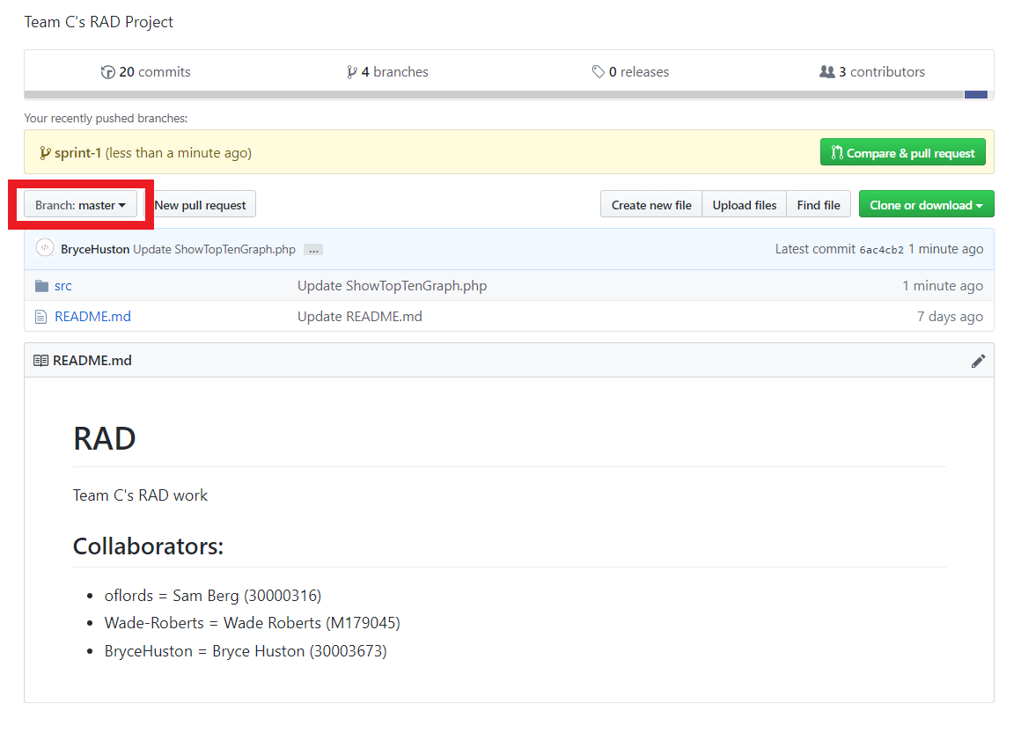

### Sprint-1 Branch

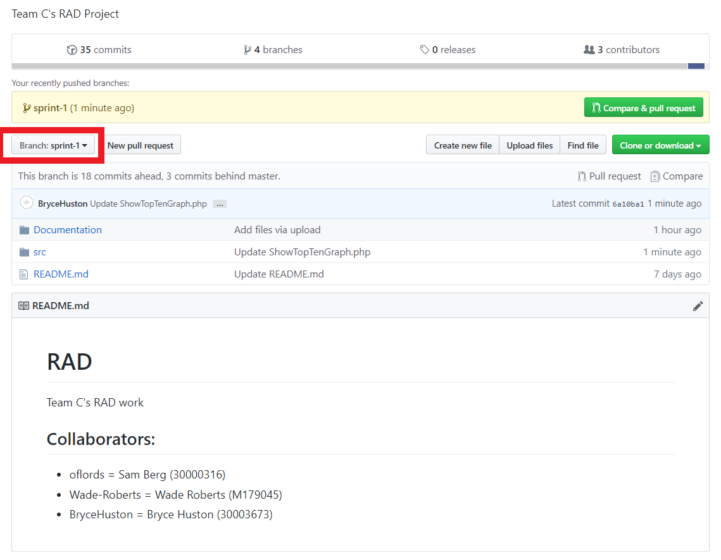

## Project Management Plan

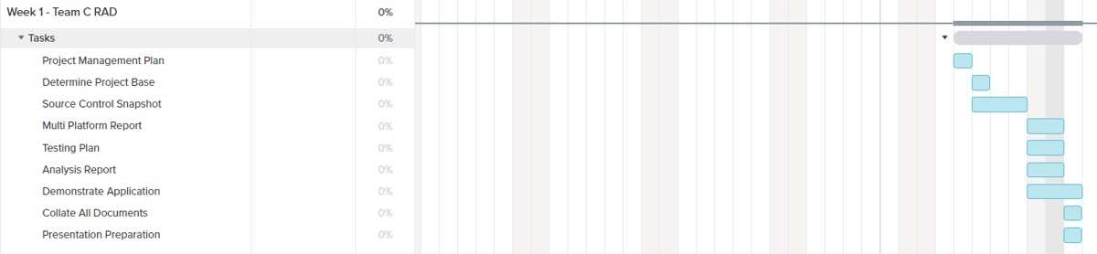

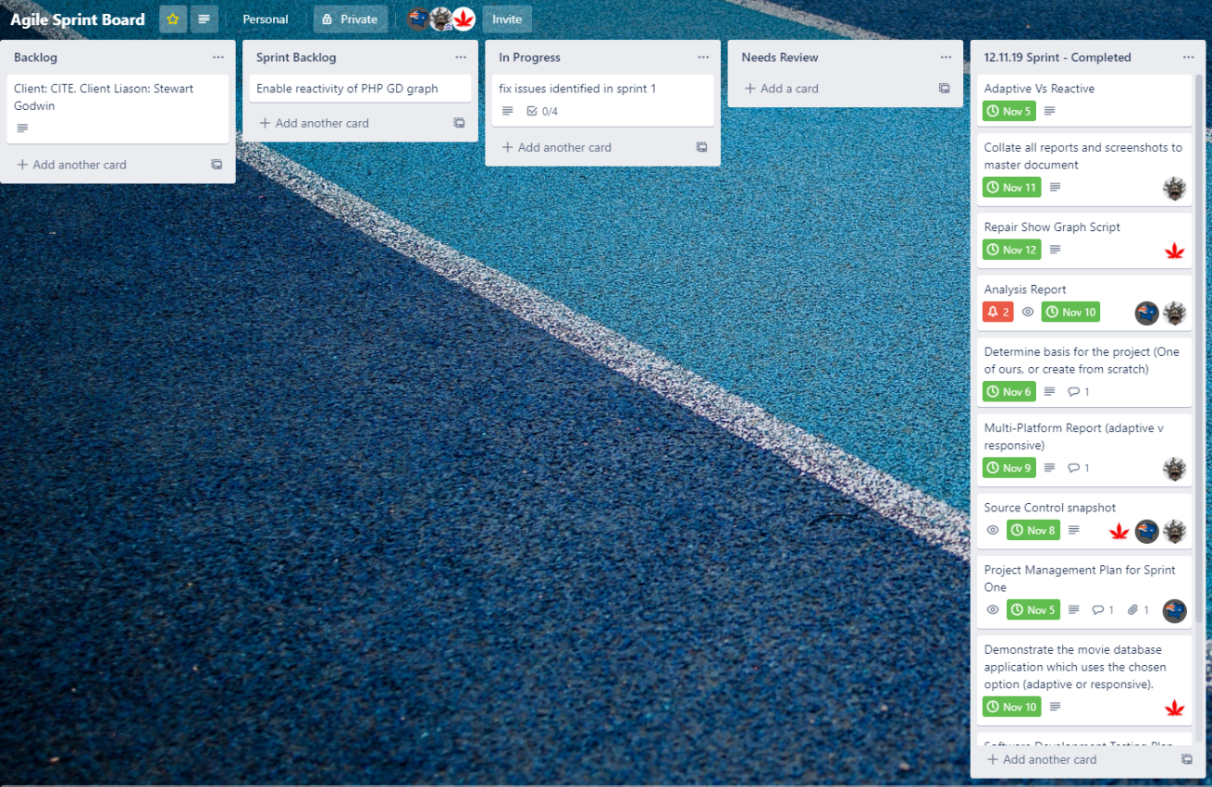

Plan started on the 5th of November and ended on the 11th of November. We generated this Gantt chart from teamgantt.com and for the rest of the project management used a task manager called Trello.

## Software Development Testing Plan

### Change Log

|  |  |  |  |
| --- | --- | --- | --- |
| **Version** | **Change Date** | **By** | **Description** |
| 1.0 | 07/11/19 | Sam | Updated the index.html to allow for better responsiveness |
| 2.0 | 10/11/19 | Sam | Allowed all php files to use the html <p> tag to conform to the responsiveness |
| 2.1 | 10/11/19 | Wade | Changed values to look better on mobile devices |
| 2.1.1 | 11/11/19 | Bryce | Fixed PHP GD graph |

### Introduction

This test plan is designed to be used within the Week 1 of RAD development to ensure quality and unity in design choices for any development handled. Through this document the correct procedures on how to create, test and deploy code will be discussed. For this project we are using the RAD methodology, which highly encourages following user feedback over following a set structure.

#### Scope

##### In-Scope

* Movie Database (This includes Installation / Configuration Testing and System / Integration Testing from CITE QA)
* Front-End Website (This includes Functional and Regression Testing, GUI and Usability Testing, Accessibility Testing, Compatibility Testing and Performance Testing from CITE QA)
* Responsiveness of website
* Multi Device Support (Desktop, Tablet, Mobile Phone)
* Overall functionality of website

##### Out of Scope

* Design of website (not needed as this week’s sprint brief specifies only the need to change reactivity)

#### Quality Objective

* Ensure the Application Under Test (AUT) conforms to functional and non-functional requirements
* Ensure the AUT meets the quality specifications defined by the client
* Bugs/issues are identified and fixed before making a development “live”
* Reactiveness of the site is working

#### Roles and Responsibilities

* Scrum Master: Lead the team and ensure all work is done on time
* Team Member: Works under the Scrum Master to work on the week’s work.

### Test Methodology

#### Overview

The reason we chose the RAD methodology was due to its flexible design and ease of use for the project provided. It also allows for us to constantly update it according to the week’s design frame and stay flexible with issues that might arise

#### Test Levels

##### Unit/Component Testing

Making sure that the base project has no errors that carried over from the last iteration.

##### Integration Testing

We test with the additional features in place very broadly to ensure that the core functionality is implemented, and previous functionality is maintained.

##### System Testing

More in-depth testing is done to make sure that in a production state no issues would occur.

##### Acceptance Testing

We test against the marking guide to ensure that anything asked by the client will be functional when presented.

#### Bug Triage

The goal of the triage is to

● To define the type of resolution for each bug

● To prioritize bugs and determine a schedule for all pending bugs.

#### Suspension Criteria & Resumption Requirements

##### Suspension Criteria:

● A bug is found during testing (Suspend that page)

● Testing tools fail to work (Suspend all)

● Testing system failure (OS Issue) (Suspend all)

● Tester has an out of work emergency (Suspend all)

##### Resumption Requirements

● The bug was fixed

● You got the testing tool to work

● Re-install OS

● Wait until issue is resolved and tester is free again.

### Test Completeness

We deem testing complete once we get:

● 100% test coverage

● All Manual & Automated Test cases executed

● All open bugs are fixed or will be fixed in next release

● All devices have been tested

● All pages have been looked through

### Test Deliverables

The test artefacts we will be using are:

* Test Plan
* Test Cases
* Bug Reports
* Test Strategy
* Test Metrics
* Customer Sign Off

### Resource & Environment Needs

#### Testing Tools

Tools we will be using to test bugs are:

● XAMPP (Host the site and MySQL)

● Firefox (Size the website to emulate other devices)

● Trello (Report Bugs)

#### Test Environment

The following software is required to run the tests:

● Windows 7 and above

### Terms & Acronyms

|  |  |
| --- | --- |
| **TERM/ACRONYM** | **DEFINITION** |
| API | Application Program Interface |
| AUT | Application Under Test |
| RAD | Rapid Application Development |

## Analysis Documentation

### CITE Business Rules for Development

CITE business rules for Software Development are rather simple when compounded, they encompass making sure the client is at the forefront of development, they include but are not limited to:

* **Ensuring Customer Quality**: CITE managed services (CITEMS) works in several ways to ensure the quality of software developed for our clients meets the expected quality. As well as instantiation of internal coding standards to ensure readability and navigability (if code is maintained by someone other than CITEMS). All code developed or presented by CITEMS will also meet international standard ISO/IEC/IEEE 12207:2017 Systems and software engineering — Software life cycle processes
* **Ensuring Customer Privacy**: Prior to commencing work on your project, involved individuals will undertake Non-Disclosure Agreements (NDA). Additionally, when you decide to retire your software from our systems, your data will be dealt with securely. The disks containing your data will be wiped and if wiping is impossible due to damage to the disc it will be degaussed, which wipes the data from the disk by destroying the magnetic fields around the disc platens.
* **Title hand-over**: Once development is completed, then you will be released the application in full, we have made a legal process facilitate the hand over, as well as all of our employees, consultants and third party workers sign paperwork which liquidates their moral rights involving development

### CITE Managed Services Quality Assurance

CITE managed services (CITEMS) Quality Assurance (QA) is made up of several policies, guidelines, tools and standards which combine to represent a Quality Management System (QMS). Topics covered by CITEMS’s QMS includes:

* **Planning**: Quality Plans are developed in order to create an applicable set of restraints for development to ensure client satisfaction
* **QA**: By establishing processes that profile project performance and ensuring that the drawn set of procedures, standards and tools are used in order to fulfil client needs.
* **Quality Control (QC)**: Performance trends are monitored and used to identify defective or inoperable code, this is done in order to ensure that all deliverable products are complete and reach expectations.

### ACME Entertainment Pty Ltd Development Requirements.

#### Functional Requirements

* When a user enters information into the text fields and attempts a search, then movies relating to the search terms will be returned from the database.
* When a user requests, a graph is displayed with information regarding the top 10 searched movies in the database.
* When a user requests a top 10 list is displayed with all information pertaining to the films returned from the database

#### Non-Functional Requirements

1. The site should be multi-platform adaptive in its Graphic User Interface (GUI) and User Interface (UI) and should be accessible on three platforms to allow freedom of use (These are Mobile, Desktop and Tablet)

## Multi-Platform Report (Adaptive VS Responsive)

This report will encompass a comparison of two design methodologies, the methodologies up for discussion are Responsive Web Design (RWD) and Adaptive Web Design (AWD), the issue which both of these methodologies try to resolve is how a browser can display a website in order for it to be displayed on multiple platforms (In this case, think of desktop, tablet and mobile (phone) platforms). This is important because end-users access websites from a multitude of devices, if there is no consideration for how the website adapts to these devices browsers widths then the website may prove to be completely defunct on those platforms. Having a website that is not available on a multi-platform basis could possibly even effect users’ opinions of your business or services. Because of this, it is integral to take on one of these design methodologies in order to allow ease of access to all end users regardless of device. These methodologies will be examined under context of development for CITE services of whom the client representative is Stewart Godwin.

RWD is a design methodology that was coined in Ethan Marcotte’s book; Responsive Web Design. RWD aims to provide optimal viewing of a website on any device, its design motifs include simple User Interfaces (UI) that contribute to easy readability and navigation presenting a better User Experience (UX) through minimizing the use of screen-based navigation such as scrolling and panning. When RWD is implemented, it is possible to open a webpage in a desktop browser and scale the width by resizing the browser window. As the webpage width changes, the page will reformat itself to a more appropriate lay-out for the devices display width. On a mobile, or other smaller width devices, this process will happen automatically as information about device width (in pixels) is identified in the network requests. Some advantages to utilizing RWD for Web Development are that it maintains uniformity of its layout. There are several templates available in order to support simple instantiation of RWD and, conversely to AWD, it is often simpler to implement (see the next paragraph for more information regarding this). However, some disadvantages regarding RWD are that due to the nature of it, there is less overall control over how the design is displayed according to the width. Additionally to this, some advertisements may be removed or otherwise obscured (which can effect otherwise sound economic decisions through restricting access to your advertisements) and there will be longer overall load times when trying to access from mobile as compared to desktop, despite the improved performance once the page has loaded. Overall, RWD is still faster than AWD when trying to access a web page and allows better search engine optimization (SEO), meaning that pages will be easier to find due to their not being multiple webpages as is present in AWD.

AWD is a design methodology that was coined by Aaron Gustafson’s book; Adaptive Web Design: Crafting Rich Experiences with Progressive Enhancement. RWD relies on creating a lay-out which responds to the current (or on load-time if on mobile) device width. AWD still serves to meet the same result of RWD, which is to create lay outs which are appropriately displayed on devices of varying widths. However, AWD and RWD achieve this through different methods, whereas RWD creates one page which will react in real time to device width changes, AWD accomplishes multi-platform design through the creation of multiple site layouts of varying device width (For example, a website lay-out will be developed at device widths of 320, 480, 760, 960, 1200 and 1600 pixels), the site will be loaded in the layout closest to the device width which is sent in the network request. Unlike RWD, AWD cannot be opened, then scaled appropriately, the page wouldn’t adjust until the device width was sent again with a value that would instantiate a layout change. Due to there being multiple website layouts, AWD will take longer to load overall (particularly if the content is not optimized with a scripting language such as JavaScript) as compared to RWD. Some advantages to utilizing AWD are it allows total control over the GUI of the website, because the sites are made to meet specific width dimensions. Additionally, advertisement can be optimized to target individuals in a range of scenarios based on data collected from access to the website, for example, if you offer marketing to an Apple certified re-seller and your site is primarily accessed by people using Apple devices then that data could be used to support decisions on how to advertise to those individuals given they work inside of Apple’s environment.

Some disadvantages to AWD are that it is highly labour-intensive, this is due to there being a Cascading Style Sheet (CSS) file for each layout meaning these files have to be coded separately in order to ensure that the layout displays the best it can in those dimensions. Additionally, AWD is harder to manage SEO with, given that there are multiple files in the site which will be scanned, possibly being skipped by the search engine in cases where it would otherwise return for a site designed with RWD.

The choice for development for this contracted project (Movie Web Database) from CITE was RWD, this was decided because there was a set number of devices that the project needed to be developed for, which were simply a tablet device, a computer browser and a mobile platform (assumed iPhone or android equivalent) so the implementation of RWD was rather simple as compared to the instantiation of AWD which would have required more coding in order to create the multiple CSS layouts that would be needed. Additionally, RWD is simpler to implement due to the number of templates which are available. RWD will present as a cost-effective and well-paced development for this project, given that a massive re-work doesn’t need to be performed to legacy databases and websites (existing) like in the case of a more established or larger project.

## Testing Documentation (Responsive Web Design Testing)

Below is a collection of images that were collected in testing of the various webpages which comprise the movie database. These images aim to show responsiveness through using Mozilla Firefox’s Responsive Design Mode tool. Each of the pages tested contains three snapshots. The first is at the resolution of 1920x1080 pixels (px), the second the native resolution of an iPad () and the third of on a Samsung S9 mobile phone (Dimensions can be checked at the top of each image).

### Index.html

#### Browser (1920x1080)

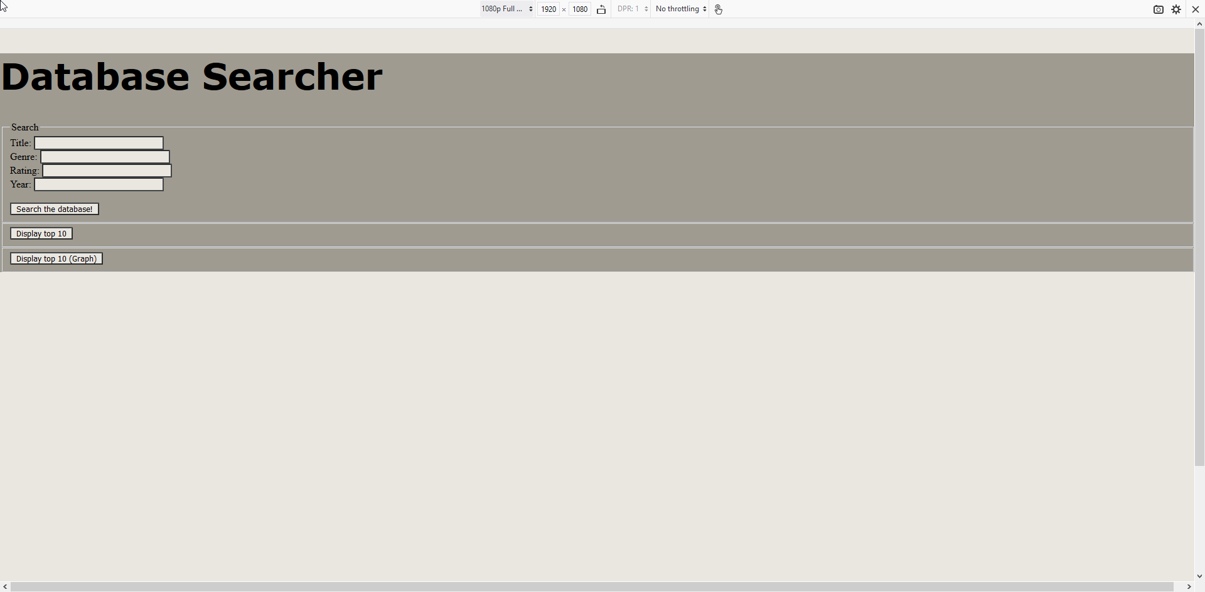

#### iPad (768x1024)

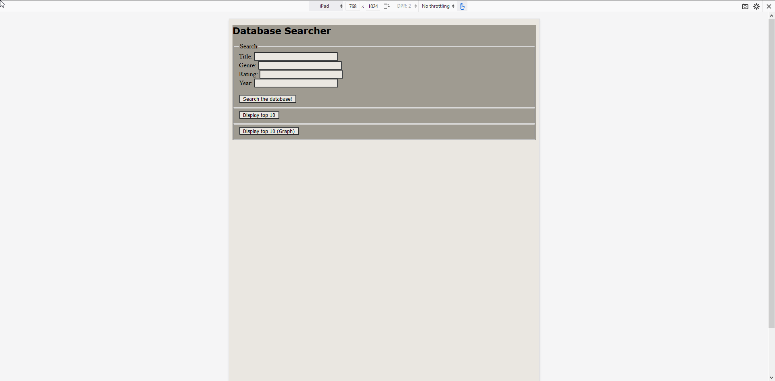

#### Samsung Galaxy S9 (360x740)

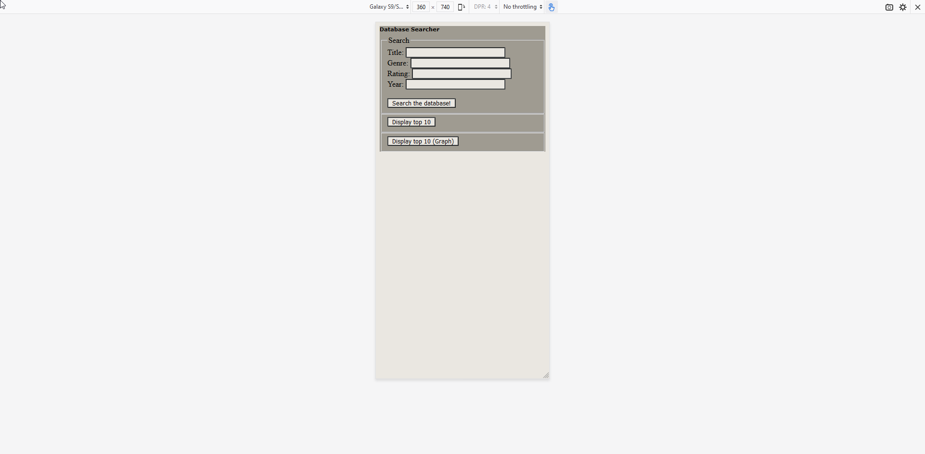

### SearchDatabase.php

#### Browser (1920x1080)

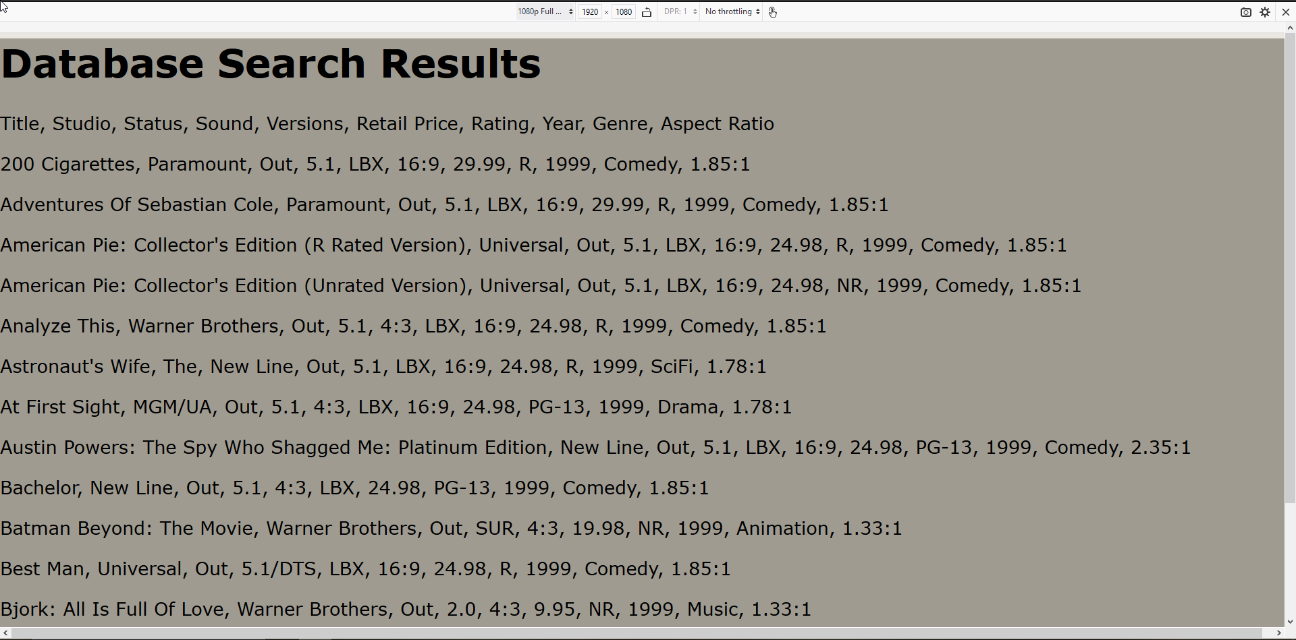

#### iPad (768x1024)

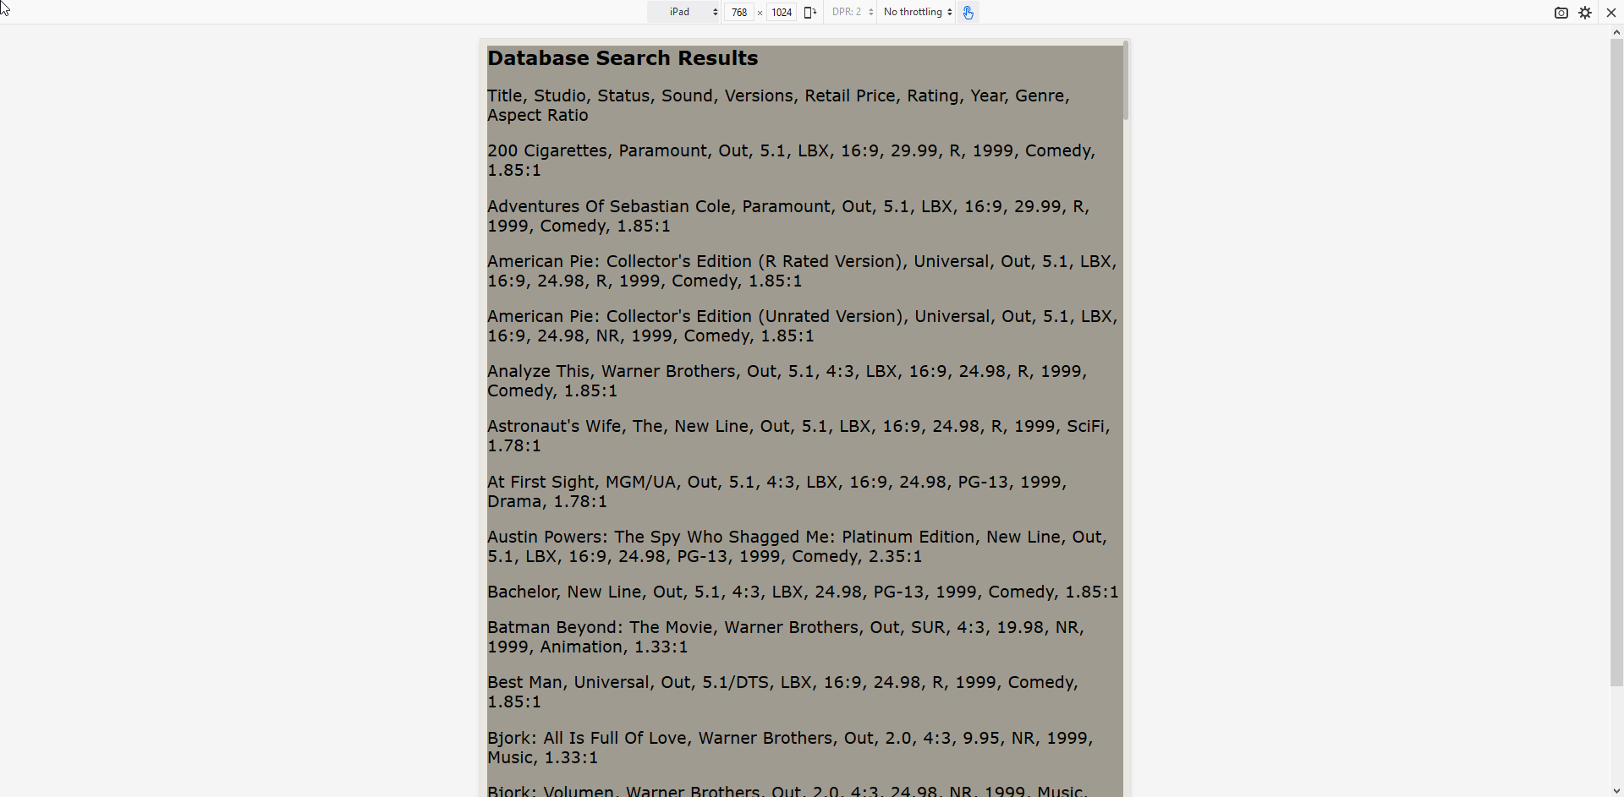

#### Samsung Galaxy S9 (360x740)

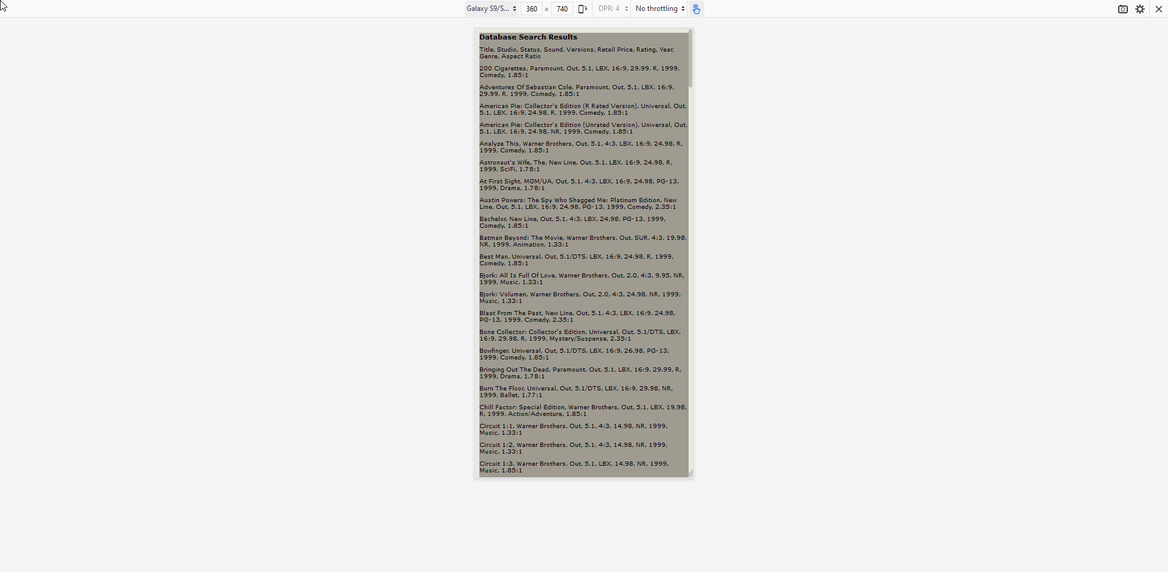

### ShowTopTen.php

#### Browser (1920x1080)

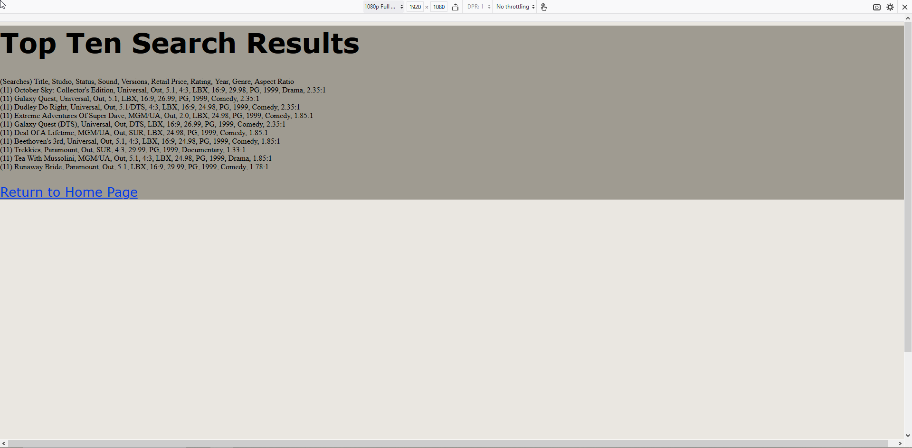

#### iPad (768x1024)

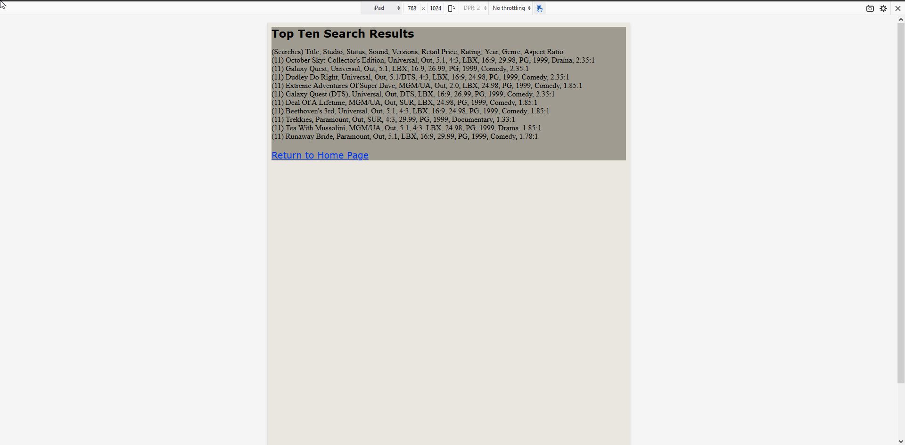

#### Samsung Galaxy S9 (360x740)

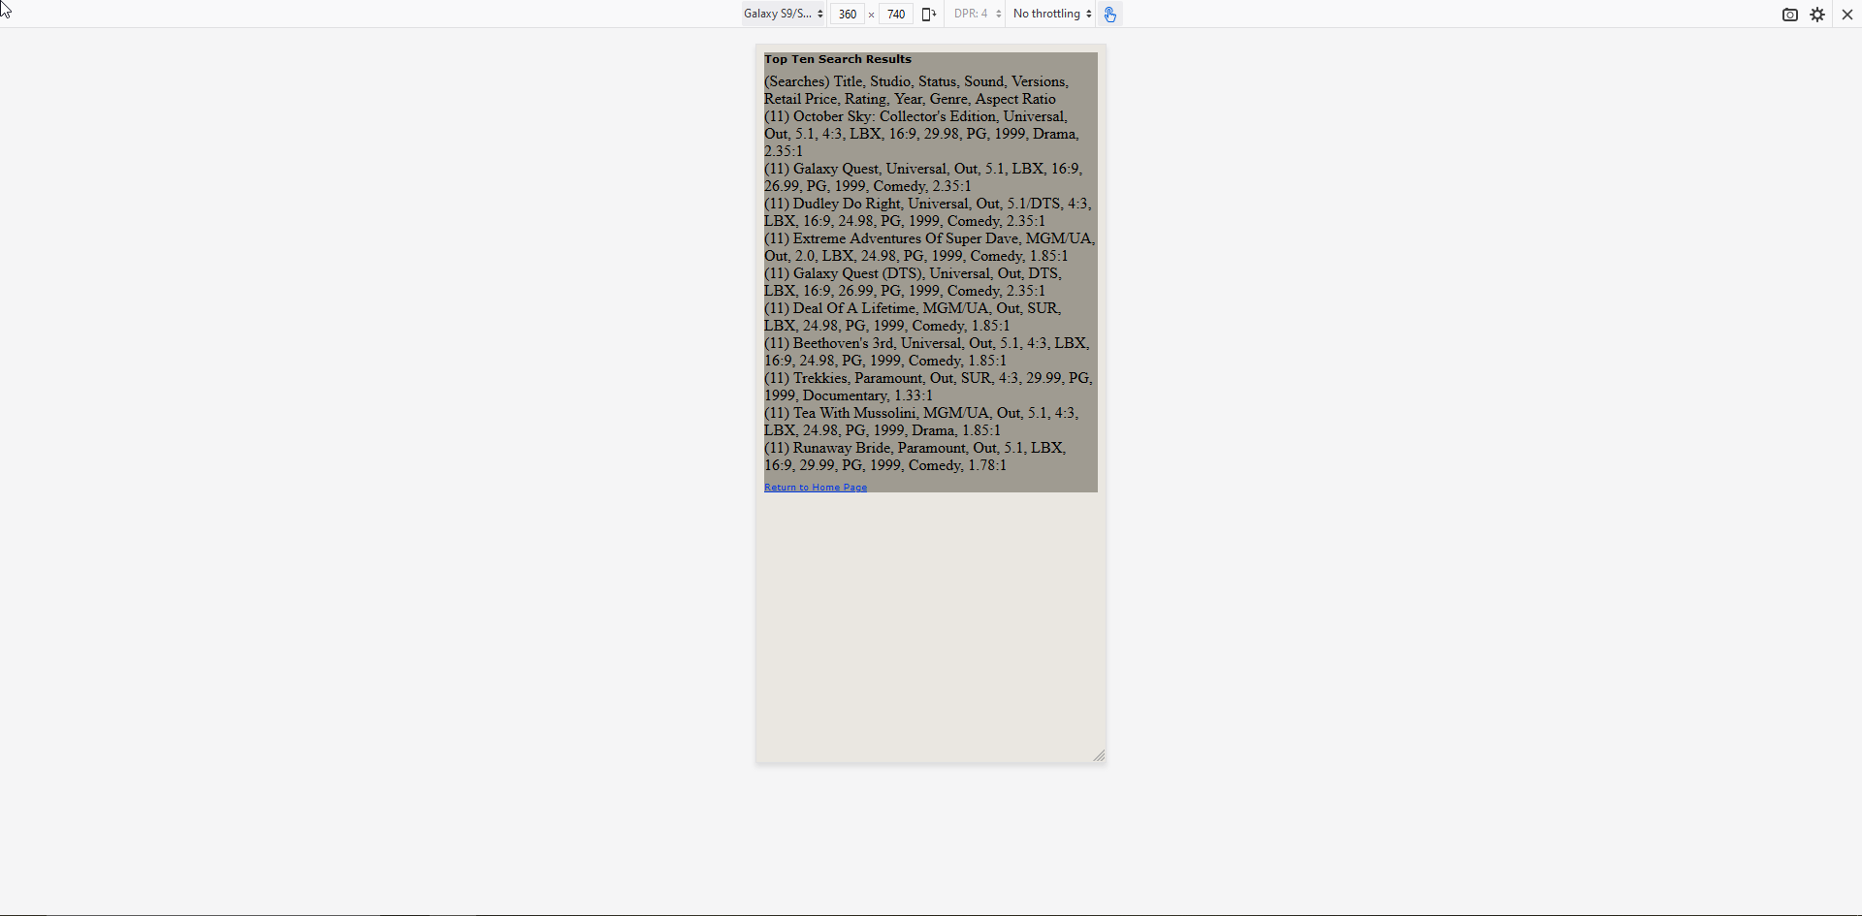

### ShowTopTenGraph.php

#### Browser (1920x1080)

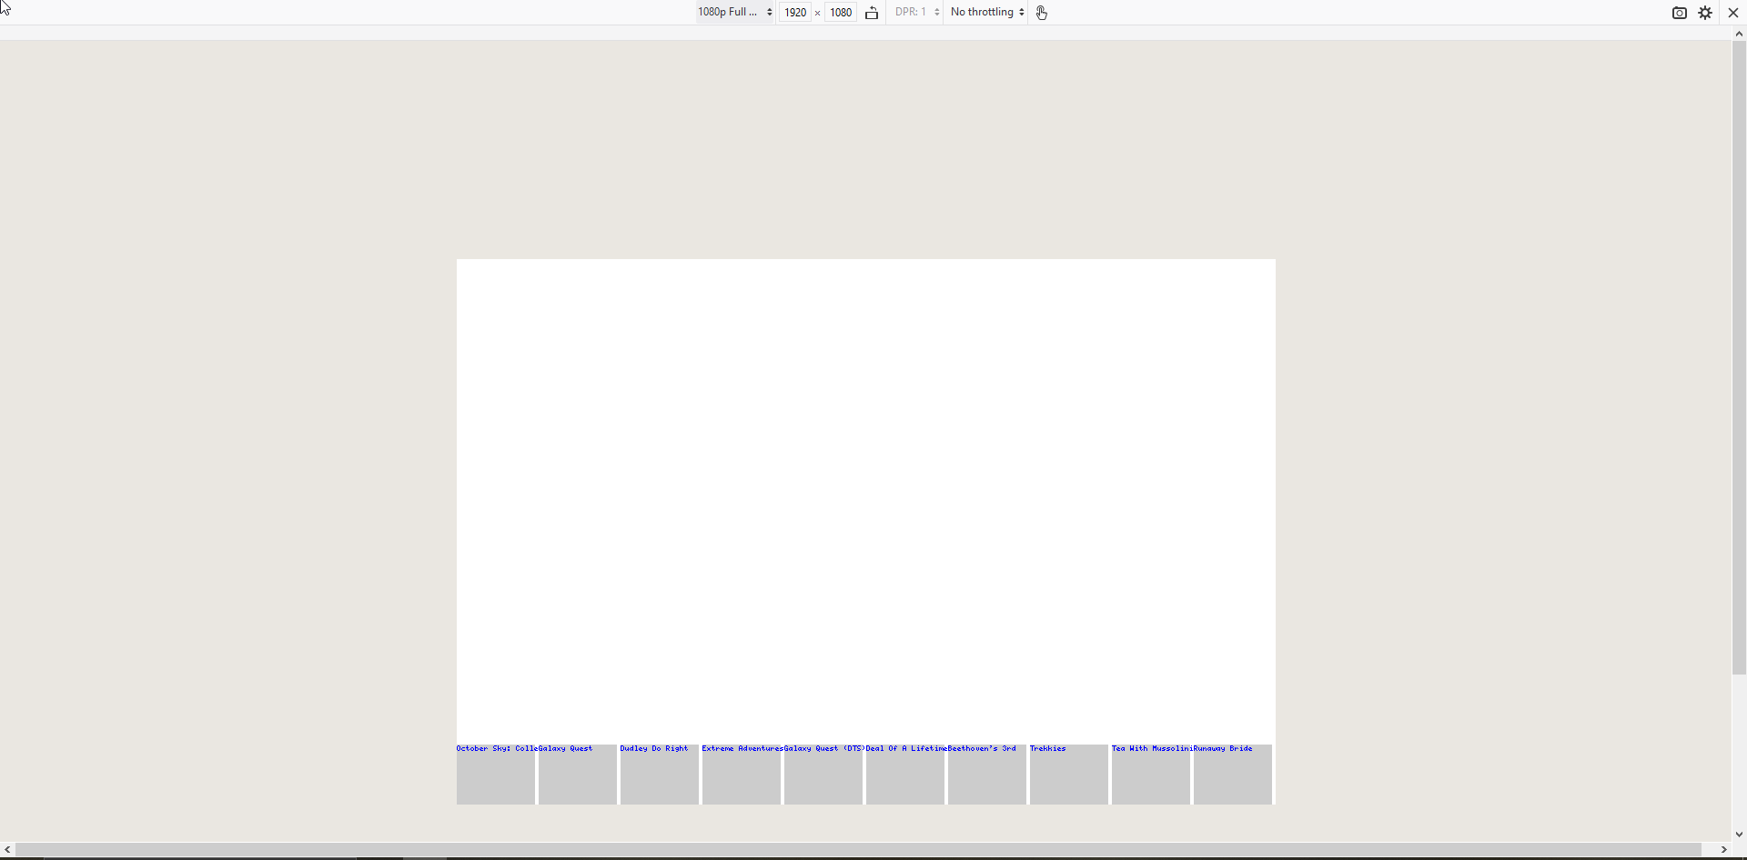

#### iPad (768x1024)

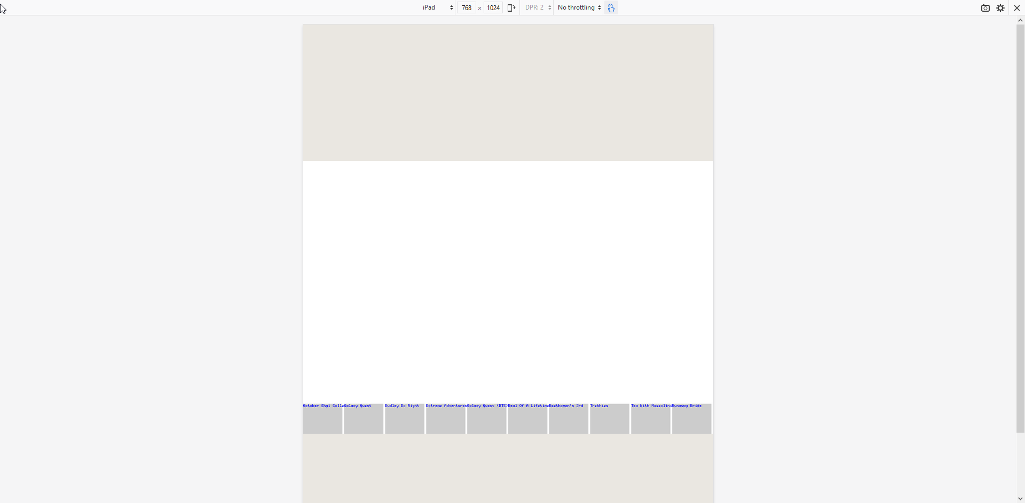

#### Samsung Galaxy S9 (360x740)

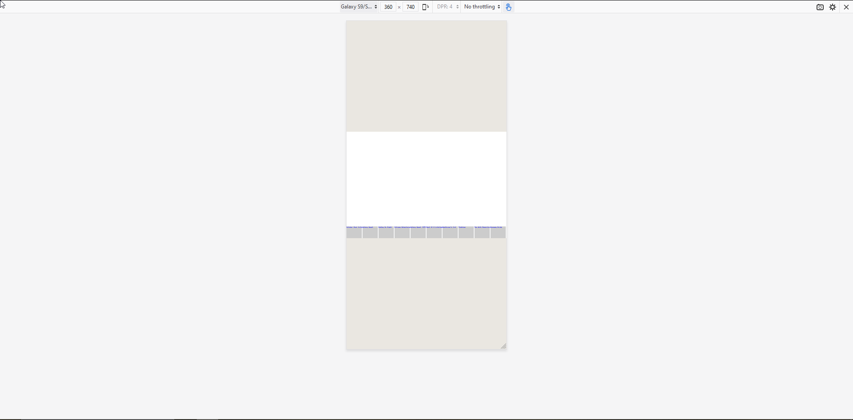

### Testing Conclusion

All tests passed aside from the PHP GD Graph sizing inside of the Samsung S9 device as this was the only test case which was difficult to read and navigate. This issue was first observed during testing on November 12, 2019. This issue has been added to the backlog to be resolved by the end of the next sprint. Some considerations need to be made about the use of PHPGD and how to best make it responsive in its operation.

# Sprint 2

Scrum Master for Sprint: Wade Roberts (M179045)

## Source Control Snapshot

### Branch (Sprint) One

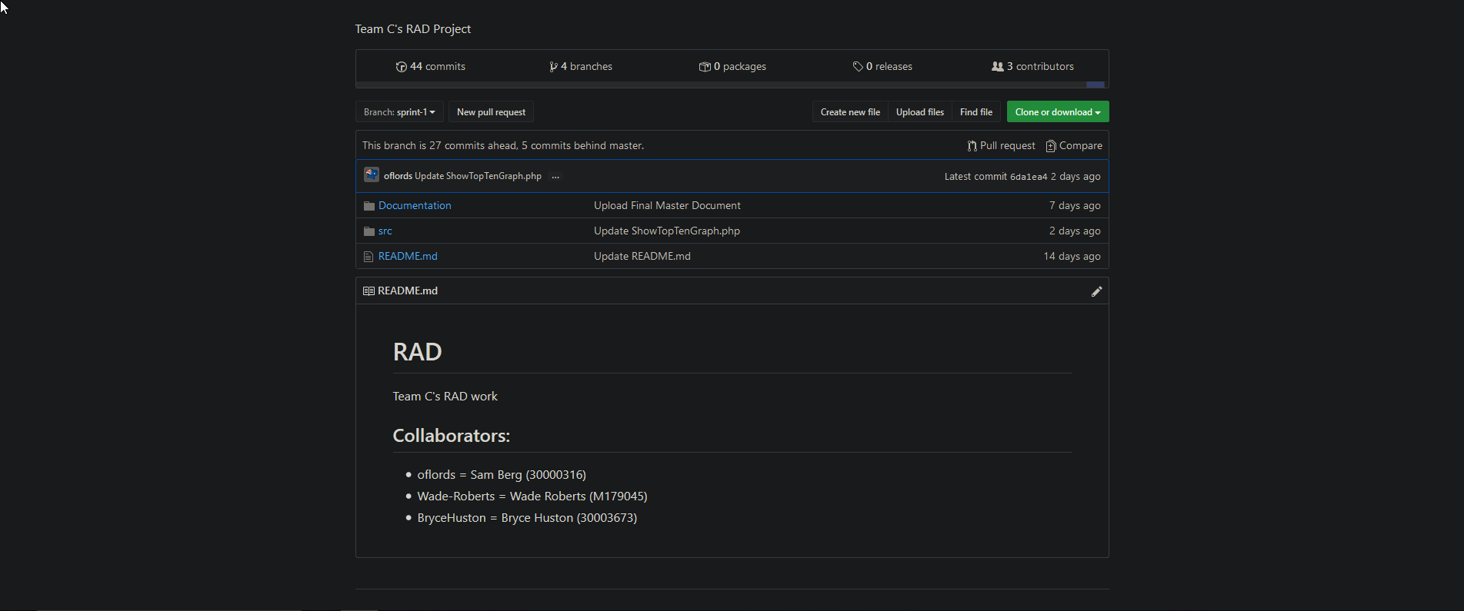

### Branch (Sprint) Two

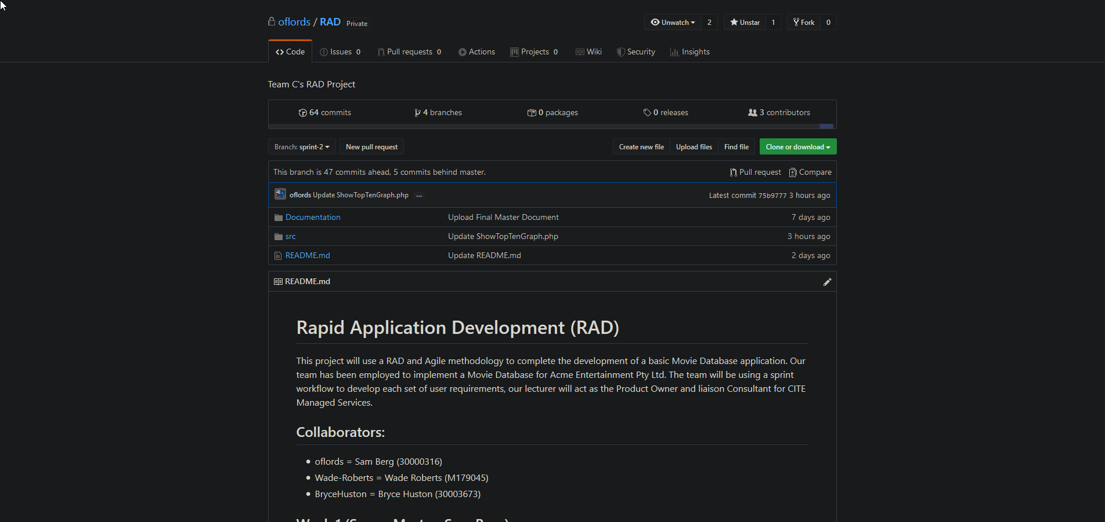

## Software Review Plan

### Introduction

This review will briefly compare the present developed Web Movies Database (WMBD) in comparison to features used in Internet Movie Databased (IMDB). There is an image comparison with some analysis which is made available through the major features of the website

### Home-Page

The home pages of each site are quite different in design and functionality. The IMDB page is more focused on current news and catchy headlines that will keep users on the site for longer. Our site is very simple in design currently, only showing functional things like searches and links to other specific areas. Our site also is not adaptive to latest news and certain things like “Opening this Week” movies, so a web developer would need to edit the code directly if something like that were to be implemented.

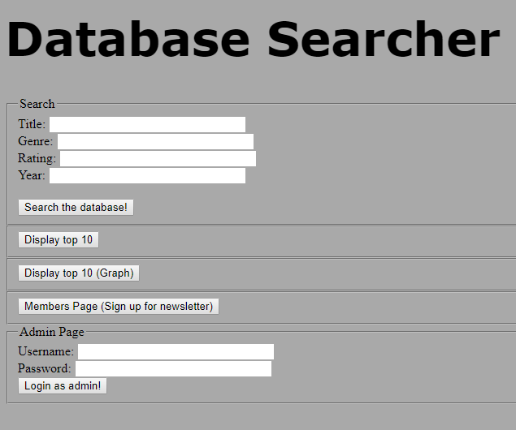

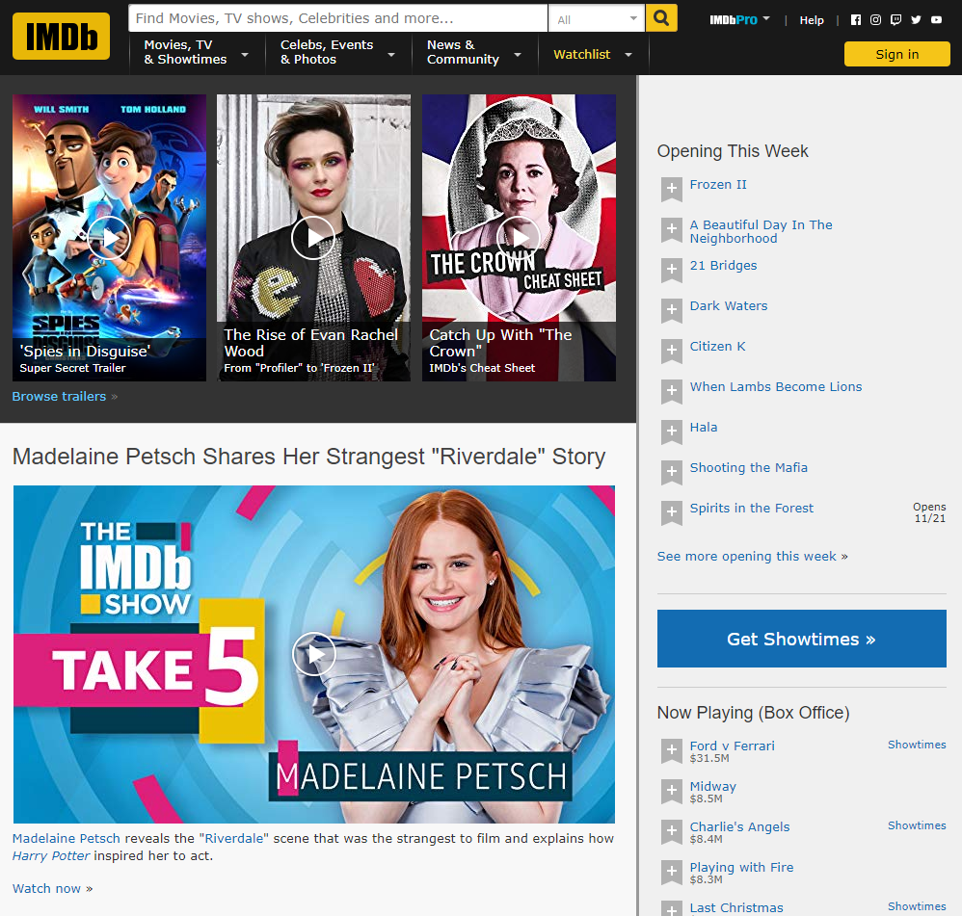

### Popular

The popular pages on each site are slightly different in actual implementation on each site but both demonstrate a similar function. The IMDB site like ours takes live data and displays it in order of largest to smallest. What the IMDB site does differently however is have multiple categories, including “Ranking”, “IMDB Rating” and “Number of Ratings”. Our “popularity” search is static, so older results that still have a higher search amount will always be displayed first, even if multiple years old.

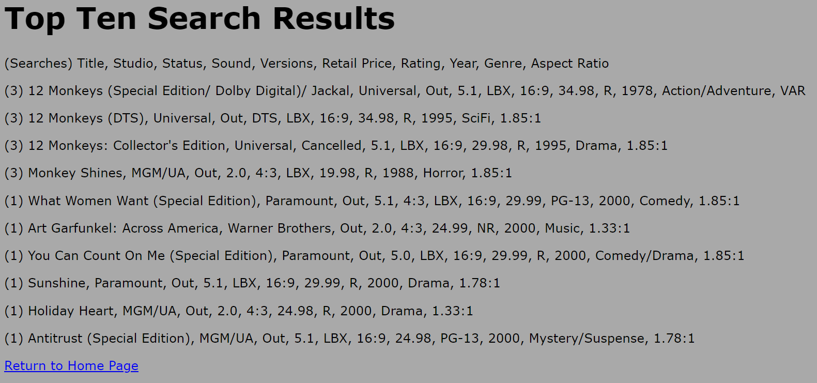

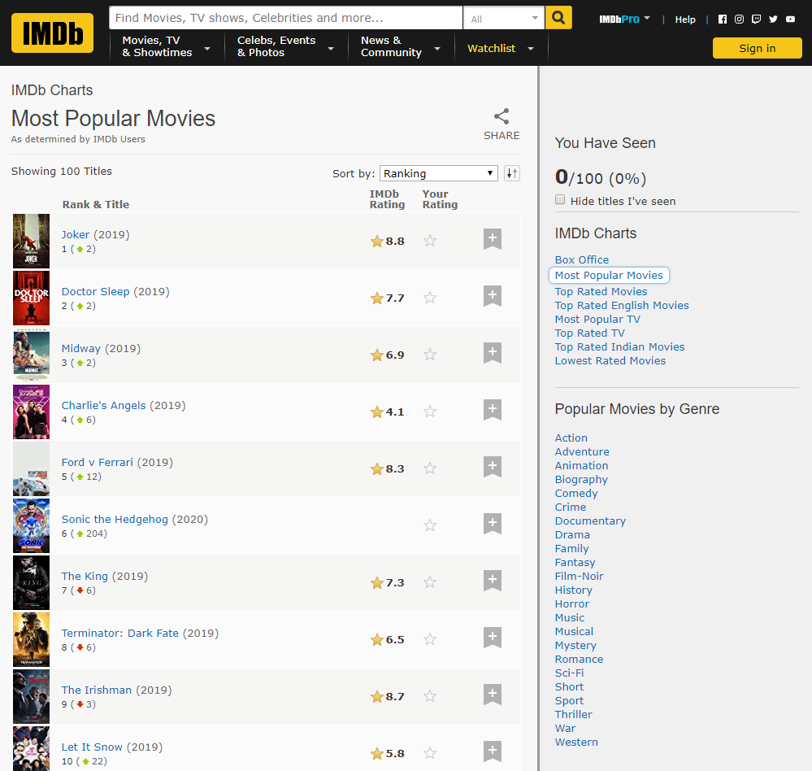

### Search

Search functions for each site are basically identical, with IMDB having more features along with some extra functionality. IMDB have “also known as” titles for movies, allowing users that might know a movie by a less popular but still known name to find the result they were looking for while we do not have that feature. IMDB also has results for more categories that we do not cover within our database.

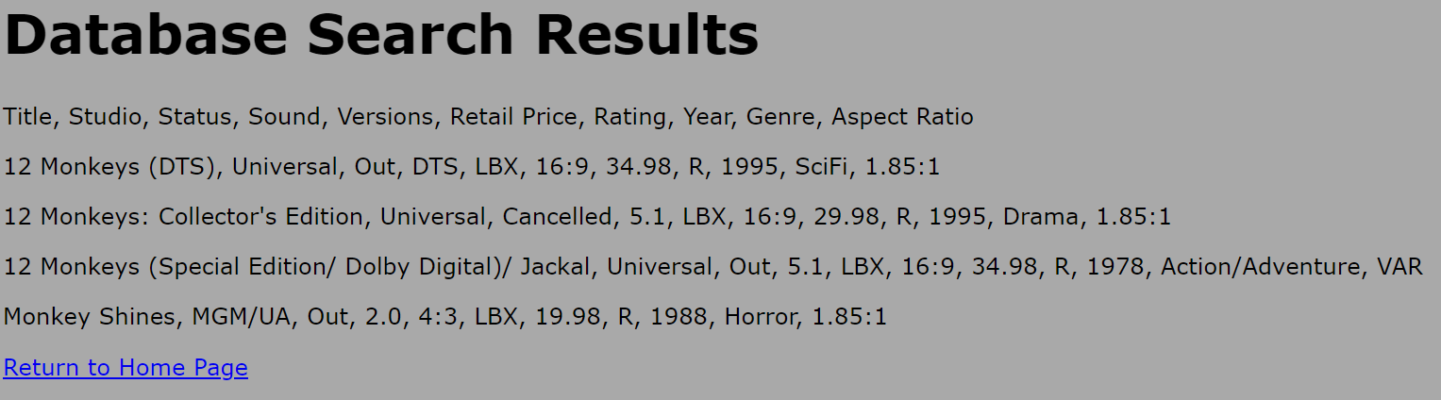

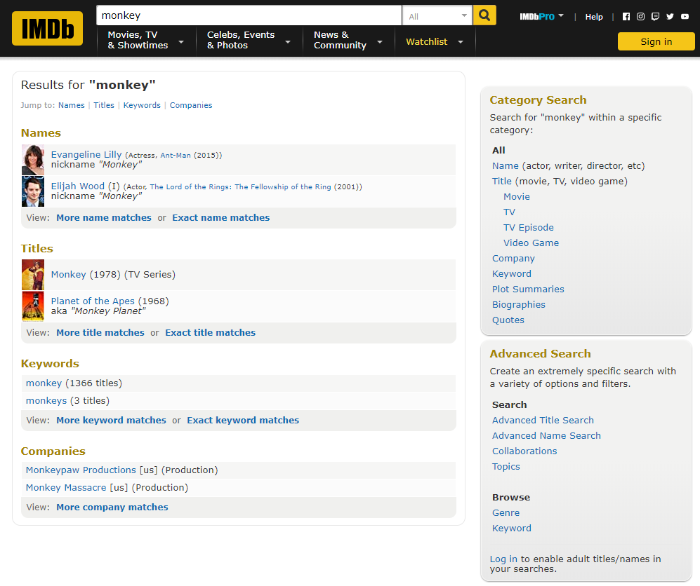

## Performance Plan

### Analyzation Tools to be Used in the Project

#### Performance Analyser (Google Chrome Extension)

https://chrome.google.com/webstore/detail/performance-analyser/djgfmlohefpomchfabngccpbaflcahjf?hl=en

Due to a lack of an externally hosted server, it was found that analyzation software primarily is built to be run on a hosted solution. In accordance with this, we opted to use Performance Analyser which is a google chrome extension. Performance analyser leaves us with a number of metrics to review and use in order to check the over-all load performance on the site. It enables us in order to investigate load time (both overall and Time to first byte (TTFB)) as well as other metrics such as rendering speeds, content delivery speed and asset-verification

### Code Optimization Tools to be Used in the Project

#### NorthCutt HTML Optimizer

NorthCutt HTML Optimizer is a web-based program in which html is inserted into it and the optimizer will remove whitespace and other erroneous code elements such as line-breaks and newlines, while a simple optimizer, it can allow for reduction of program footprint which leads to faster overall load time though a reduction of reading to be performed at load-time.

#### CSS Compressor

CSS compressor is another tool, which is not dissimilar to NorthCutts HTML Operators in regard to being an online platform and stripping erroneous content from the files that are scanned. However, for the CSS compressor, there is the option to also minify your CSS (meaning that the code is condensed, this does lower readability, but it is logically easier for the browser to transverse) to 4 different levels, as levels go up, the readability lowers considerably, but so does the overall footprint of the CSS. Leading to lower load which may increase load-times (less likely for present project, but could still be significant.)

## Project Management Plan

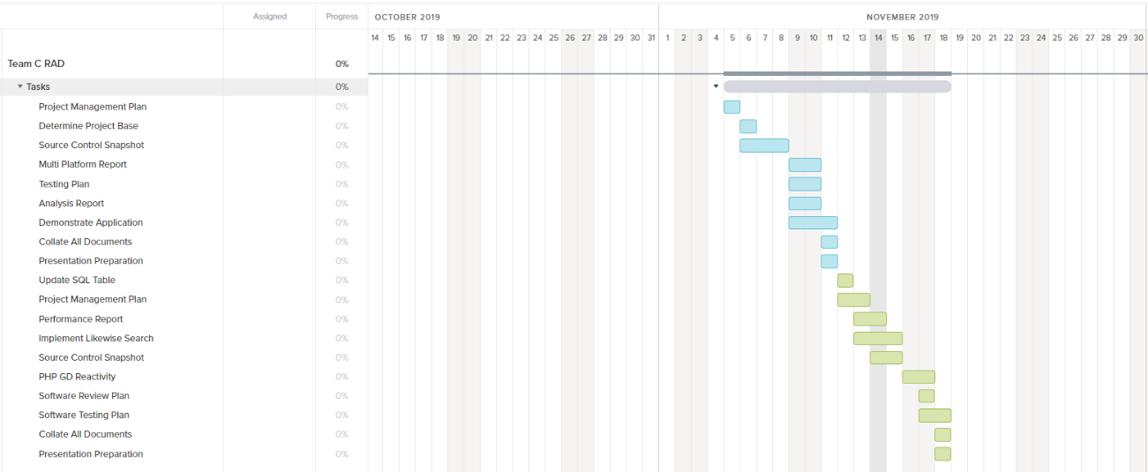

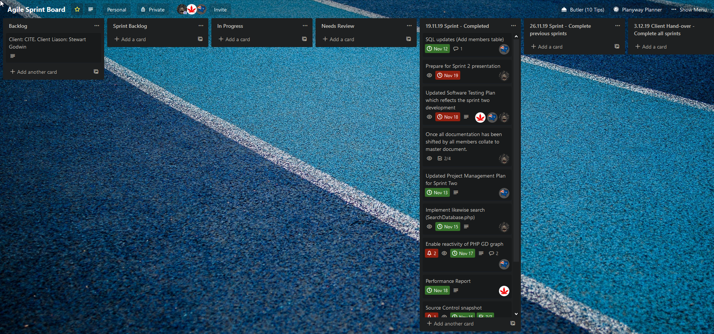

This Trello board was utilized in order to track development from the period of 11/11/19 to the 19/11/19, again the Gantt chart was generated from the Trello board using the Team Gantt Plug-in whilst Trello was used for the bulk of task management on a day-to-day basis

## Software Development Testing Plan

### Change Log

|  |  |  |  |
| --- | --- | --- | --- |
| **Version** | **Change Date** | **By** | **Description** |
| 2.2 | 12/11/19 | Sam | Updated database structure |
| 3.0 | 14/11/2019 | Sam | Added member creation |
| 3.1 | 16/11/19 | Sam, Wade | Updated page design, search functionality and added functioning admin page |
| 3.2 | 17/11/19 | Bryce | Changed github structure |
| 3.3 | 18/11/19 | Sam | Security changes, graph scalability and changed database structure again |
| 3.4 | 19/11/19 | Wade, Sam | Added notification and newsletter functionality, changed graph page to have background |

### Introduction

This test plan is designed to be used within the Week 2 of RAD, iterating off the Week 1 plan, to ensure quality and unity in design choices for any development handled. Through this document the correct procedures on how to create, test and deploy code will be discussed. For this project we are using the RAD methodology, which highly encourages following user feedback over following a set structure.

#### Scope

##### In-Scope

* Movie Database (This includes Installation / Configuration Testing and System / Integration Testing from CITE QA)
* Front-End Website (This includes Functional and Regression Testing, GUI and Usability Testing, Accessibility Testing, Compatibility Testing and Performance Testing from CITE QA)
* Responsiveness of website
* Multi Device Support (Desktop, Tablet, Mobile Phone)
* Overall functionality of website
* Integration of new systems into existing project via GitHub
* Access to DBMS through verified admin
* Communication between admin and userlist (incoming: request removal, outgoing: Newsletters and notifications)

##### Out of Scope

* Reactivity of website (reactivity was completed last week, still needed for new features but not a marking point)

#### Quality Objective

* Ensure the Application Under Test (AUT) conforms to functional and non-functional requirements
* Ensure the AUT meets the quality specifications defined by the client
* Bugs/issues are identified and fixed before making a development “live”
* Reactiveness of the site is working

#### Roles and Responsibilities

* Scrum Master: Lead the team and ensure all work is done on time
* Team Member: Works under the Scrum Master to work on the week’s work

### test Methodology

#### Overview

The reason we chose the RAD methodology was due to its flexible design and ease of use for the project provided. It also allows for us to constantly update it according to the week’s design frame and stay flexible with issues that might arise

#### Test Levels

##### Unit/Component Testing

Making sure that the base project has no errors that carried over from the last iteration.

##### Integration Testing

We test with the additional features in place very broadly to ensure that the core functionality is implemented, and previous functionality is maintained.

##### System Testing

More in-depth testing is done to make sure that in a production state no issues would occur.

##### Acceptance Testing

We test against the marking guide to ensure that anything asked by the client will be functional when presented.

#### Bug Triage

The goal of the triage is to

● To define the type of resolution for each bug

● To prioritize bugs and determine a schedule for all pending bugs.

#### Suspension Criteria & Resumption Requirements

##### Suspension Criteria:

● A bug is found during testing (Suspend that page)

● Testing tools fail to work (Suspend all)

● Testing system failure (OS Issue) (Suspend all)

● Tester has an out of work emergency (Suspend all)

##### Resumption Requirements

● The bug was fixed

● You got the testing tool to work

● Re-install OS

● Wait until issue is resolved and tester is free again.

#### Test Completeness

We deem testing complete once we get:

● 100% test coverage

● All Manual & Automated Test cases executed

● All open bugs are fixed or will be fixed in next release

● All devices have been tested

● All pages have been looked through

#### Test Deliverables

The test artefacts we will be using are:

* Test Plan
* Test Cases
* Bug Reports
* Test Strategy
* Test Metrics
* Customer Sign Off

#### Testing Tools

Tools we will be using to test bugs are:

● XAMPP (Host the site and MySQL)

● Firefox (Size the website to emulate other devices)

● Google Chrome (Usage of performance extension)

● Trello (Report Bugs)

#### Test Environment

The following software is required to run the tests:

● Windows 7 and above

#### Terms & Acronyms

|  |  |
| --- | --- |
| **TERM/ACRONYM** | **DEFINITION** |
| API | Application Program Interface |
| AUT | Application Under Test |
| RAD | Rapid Application Development |

## Testing Documentation

### Test Cases

#### User can sign up for (and Receive) monthly email



User information is entered, email checkbox selected

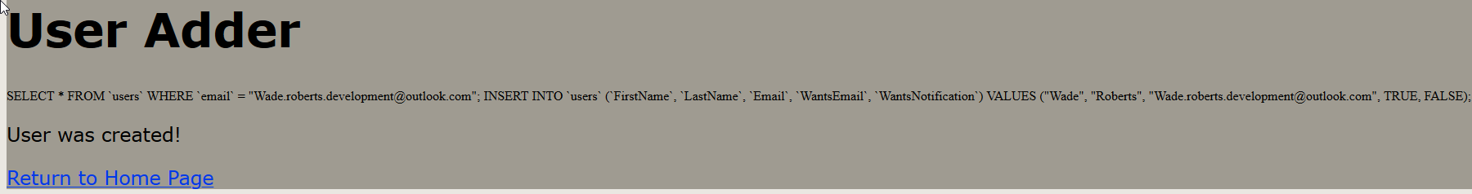

Shows query applied to database, alerts user of creation

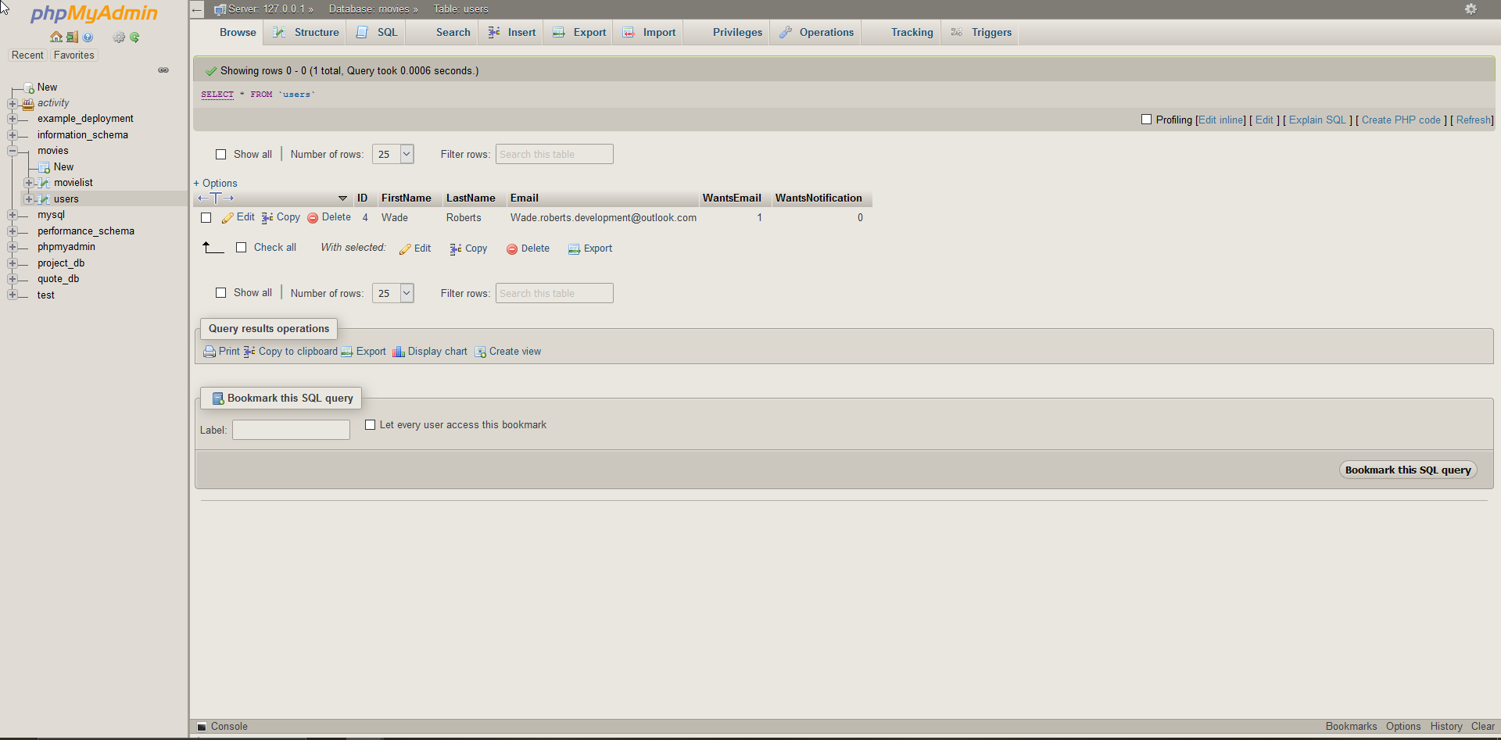

User has been added to database.

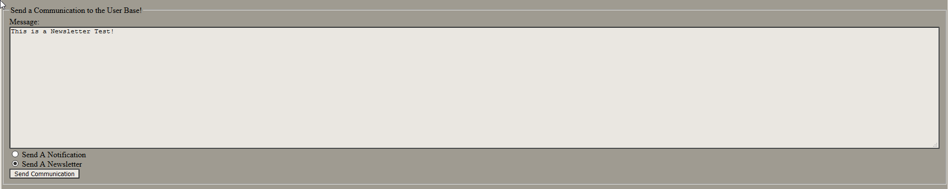

Admin writes Newsletter email (this function is inside the admin log-in page (**User: admin Pass: admin**)

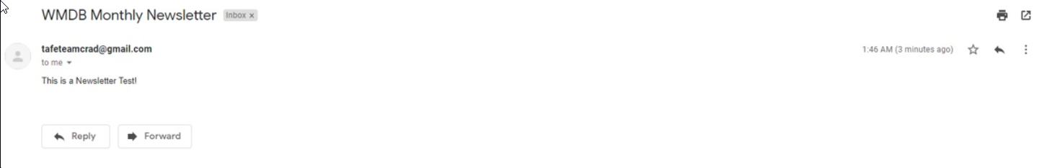

User receives email newsletter when pushed from admin

#### User can Sign Up for (and Receive) Newsflash Notification



User information is entered, notification checkbox selected

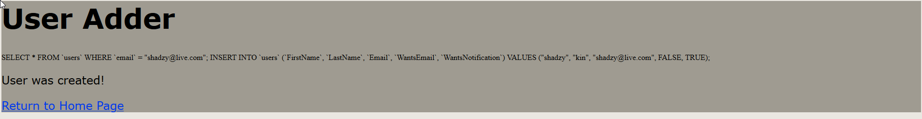

Show query applied and alert user of creation



User has been added to database

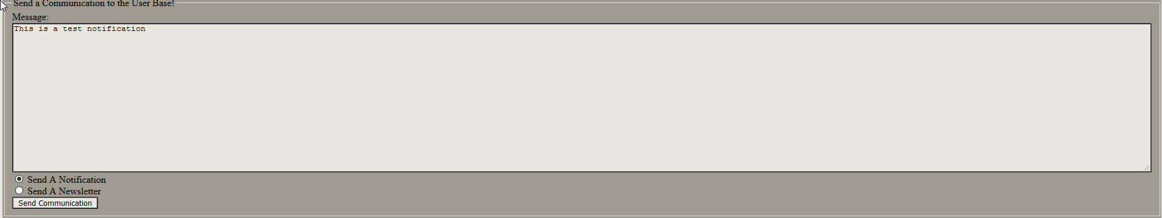

Admin writes notification (newsflash) email (this function is inside the admin log-in page (**User: admin Pass: admin**)

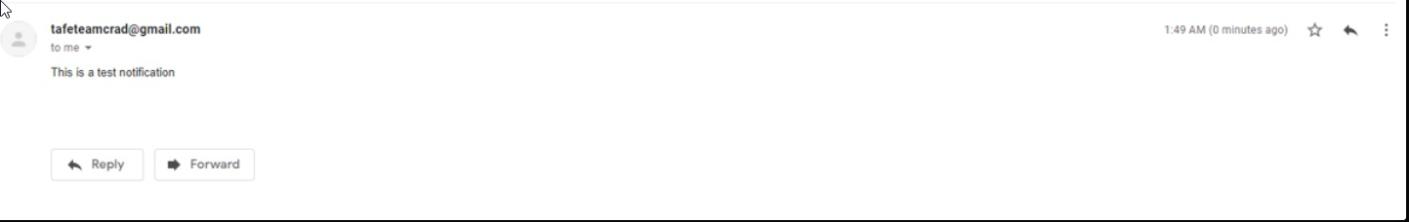

User receives email newsletter when pushed from admin

#### User can sign up for both communications simultaneously



User information is entered, both communication checkboxes are checked

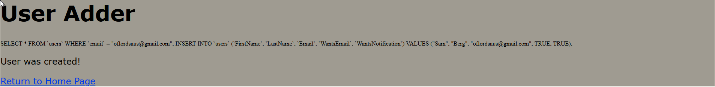

Show query applied and alert user of creation

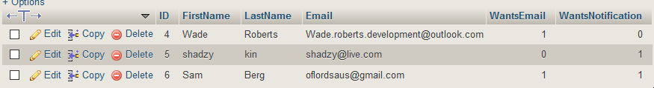

#### User can Request Removal from Admin

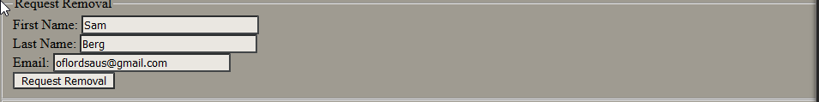

Users fills out information in request removal field-set

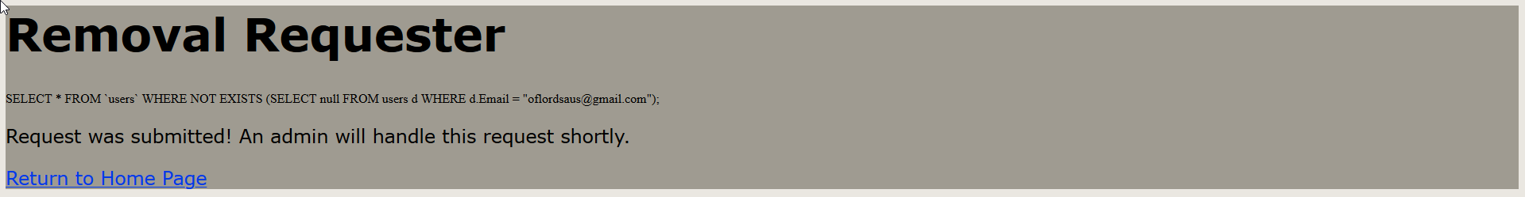

User is shown applied query to find their email and notified that an admin has been alerted

#### Admin Receives Removal Request Via Email

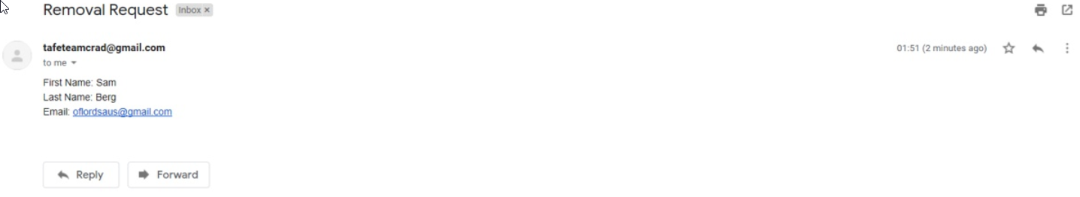

The Gmail account generates an email which it then sends to the same email address It was created from with the information needed for the removal request

#### Admin Removes Member from Database Post Request and can Access All Users

1. First method is done through accessing admin page login and filling the email into the remove account field-set

Admin is shown the query applied to database and alerted of a successful removal

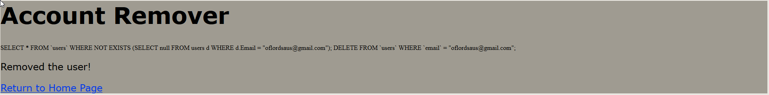

User is removed from database

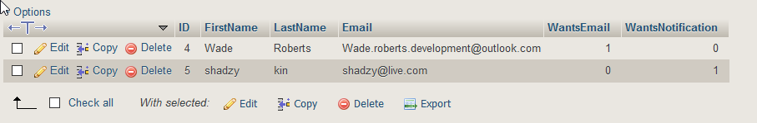

1. Second method is through accessing the DBMS (specifically the associated database) directly from the admin page using the associated button



Admin is taken to the DBMS for the WMDB

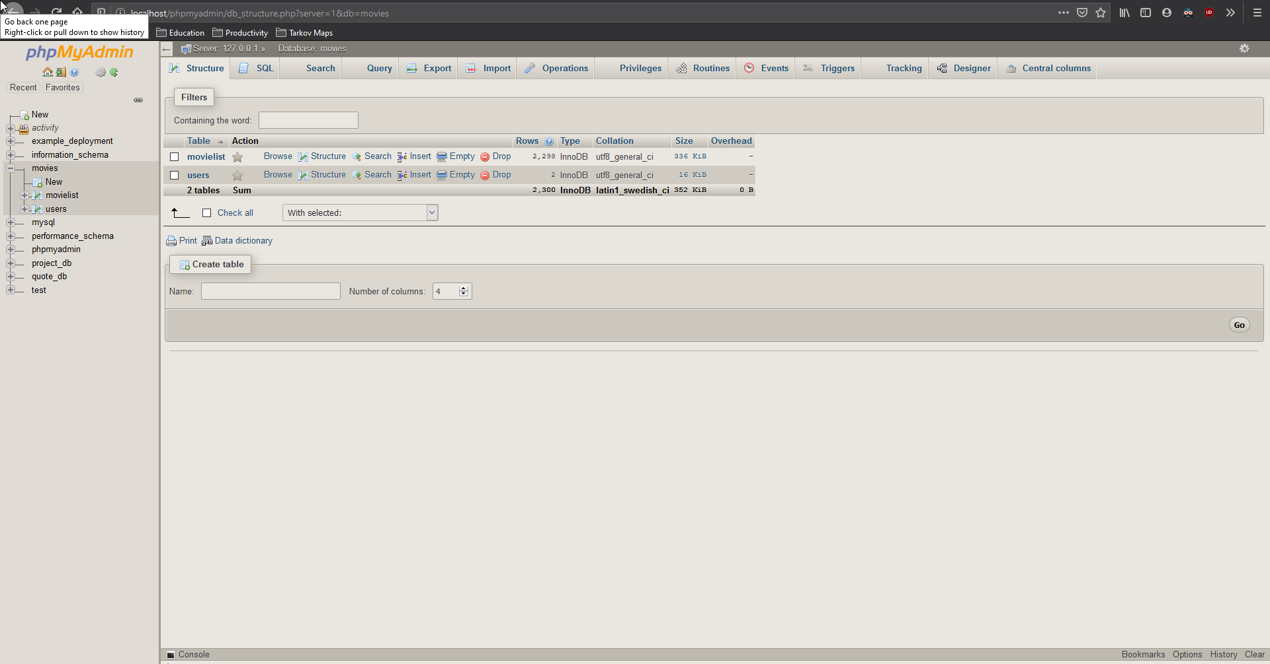

Admin accesses users table. All users are displayed, from here a row can be selected and deleted utilizing the gui function

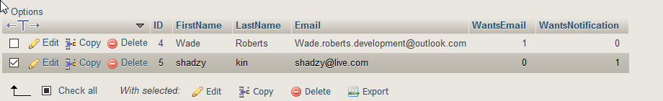

### Testing Conclusion

In conclusion, all tests cases were undertaken and deemed successful, however, when attempting to replicate the functionality of the program “on-site” inside of the clients environment there was issues regarding the Simple Mail Transfer Protocol (SMTP) which cause inability to show the client directly. These issues do not impose on the developers inside of the testing environment; however, the program is not intended to be hosted locally when moved into production. This means that concepts regarding the email communication will need to be finalized when a non-locally hosted solution is presented.

# Sprint 3

***Scrum Master For Sprint: Bryce Huston***

## Source Control Snapshots

### Branch sprint-2

### 

### Branch sprint-3

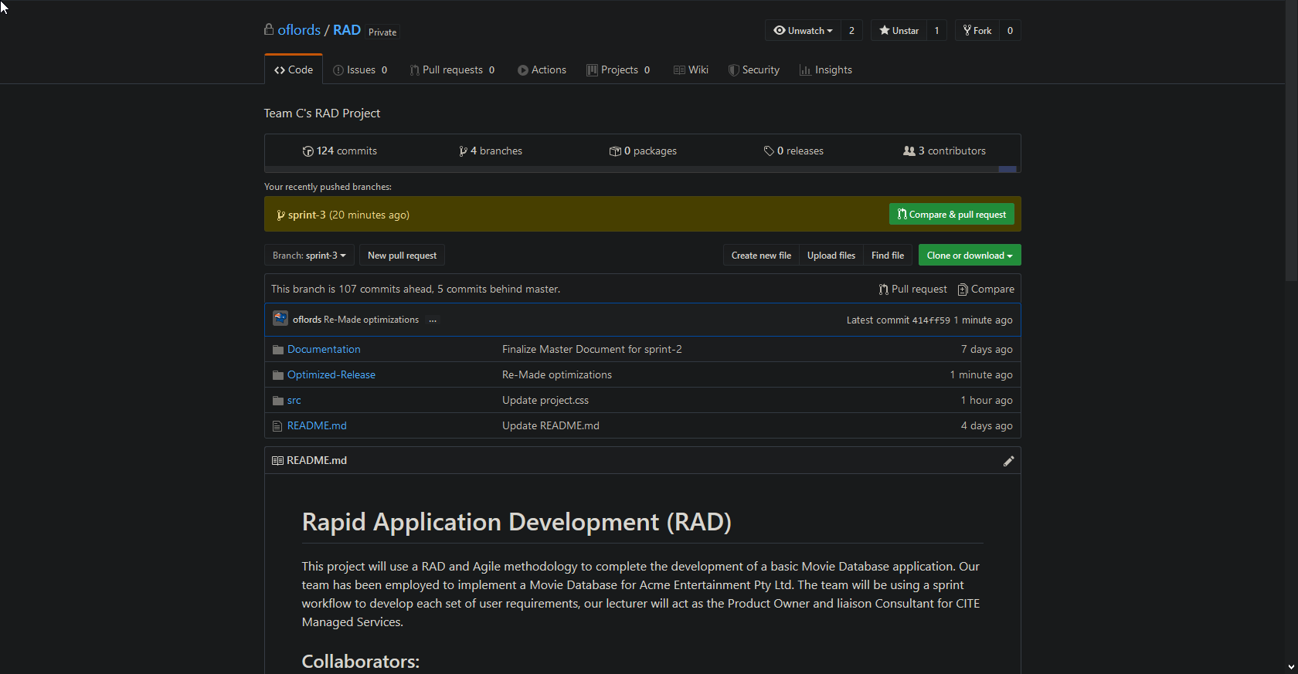

## Optimisation Report

### Tools Used

#### CSS Compressor

https://csscompressor.com/

CSS compressor is a tool in which CSS is optimized, in this case a number of functions occur. These functions include the stripping of erroneous white space and additional line breaks that are not necessary for code to run. Additionally, to this striping of erroneous elements is the ability to compress CSS, lowering its legibility while maintaining its ability to be read correctly by the browser.

#### Compresspng.com

CompressPNG.com was used in order to shrink the file size of icons (within .png format) which were used as linked assets in the creation of the website (examples of these are the clapboard inside of index.html)

#### Ezgif.com/optimize (35 point optimization)

Ezgif is a tool which shrinks the overall size of gifs, it does this through a number of options, including the resolution of the GIF, the frame rate at which it runs at and pixels per inch (PPI) “Point optimization” refers to the weight of the compression, 35 is quite a light optimization.

#### Htmlcompressor.com/compressor

HTMLcompressor.com is a tool which can be used to compress a multitude of file types, including file types nested inside of other files (For example, if you have a PHP file with included html outside of the PHP markers, the site is capable of handling both the PHP and html synchronously)

### Why Were These Tools Chosen

The tools above were chosen for a few reasons, these include

* All of these tools are available online through a website, meaning they are easy to access and there is no need to externally host in any way to simply optimize.
* The tools allow a great amount of control over the assets affected (both the image compressors as well as the source code directly)
* HTMLCompressor.com/Compressor can be used on files which include numerous languages regardless of base file type, so it can be applied to PHP, HTML and JavaScript(JS) that resides inside of a single .html file.

## Metrics And Optimization results

### Total File Size Before Compression and Optimization

2.28MB

### Total File Size After Compression and Optimization

0.97MB (57% decrease to total file size)

### Performance Analyzer Output Before Compression

#### Index.html

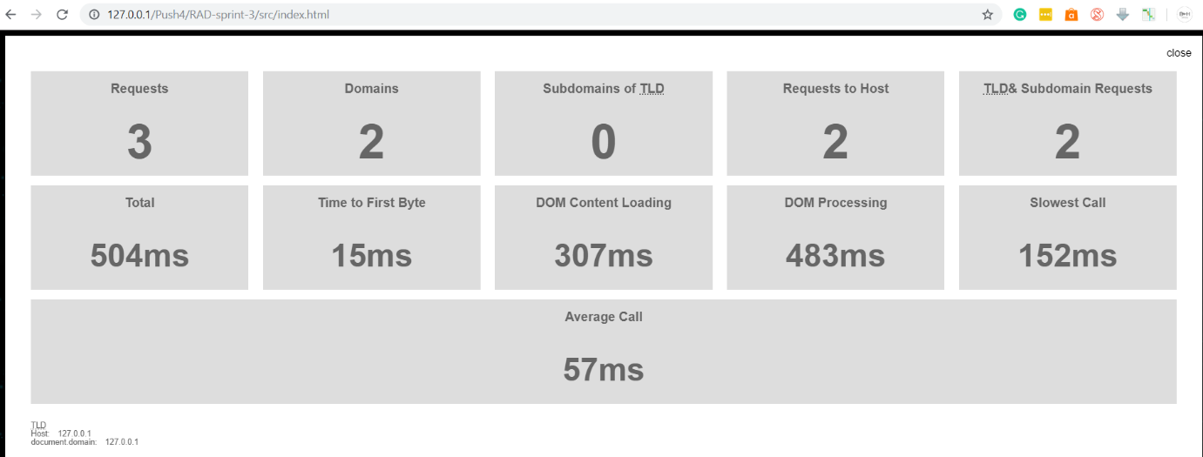

#### Admin.php

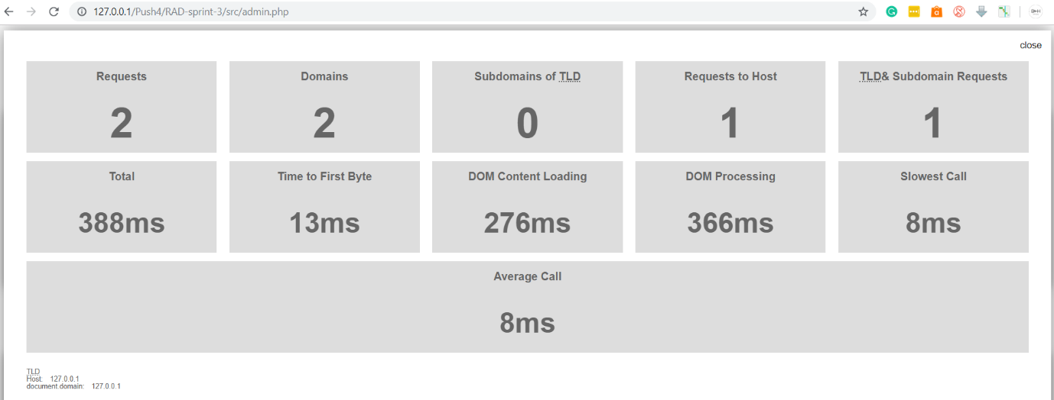

#### Member.html

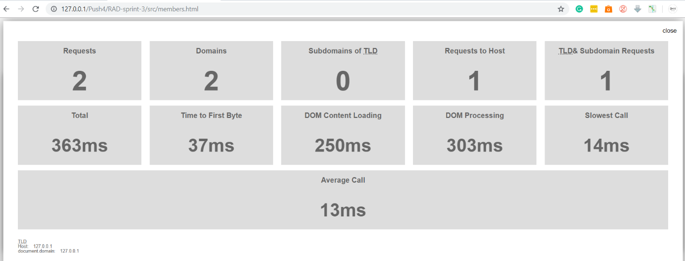

#### ShowTopTen.php

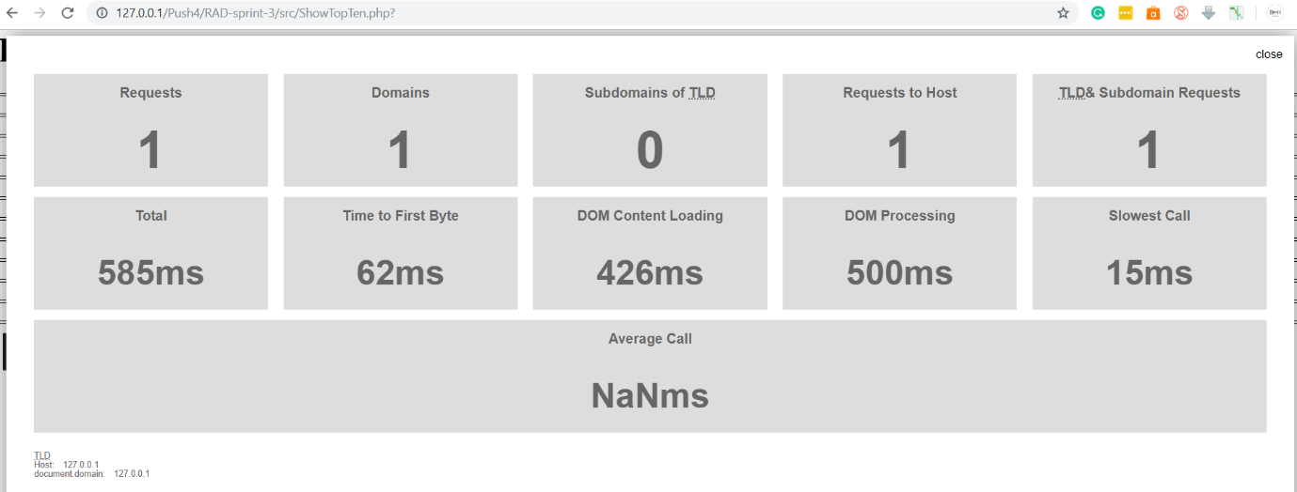

#### ShowTopTenGraph.php

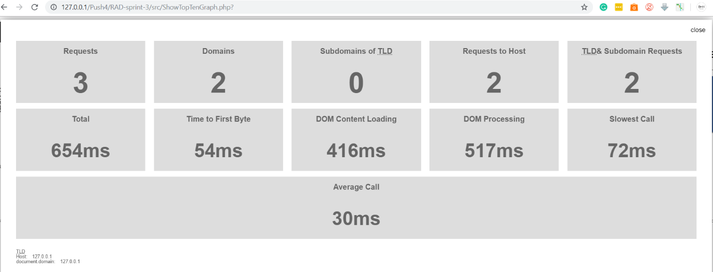

#### ShowTopTenRatings.php

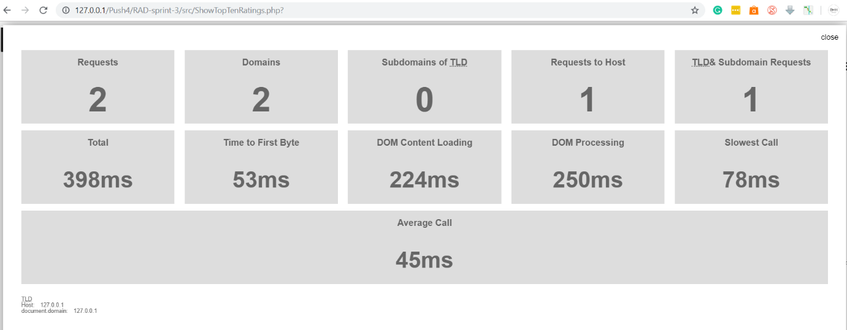

### Performance Analyzer Output After Compression

#### Index.html

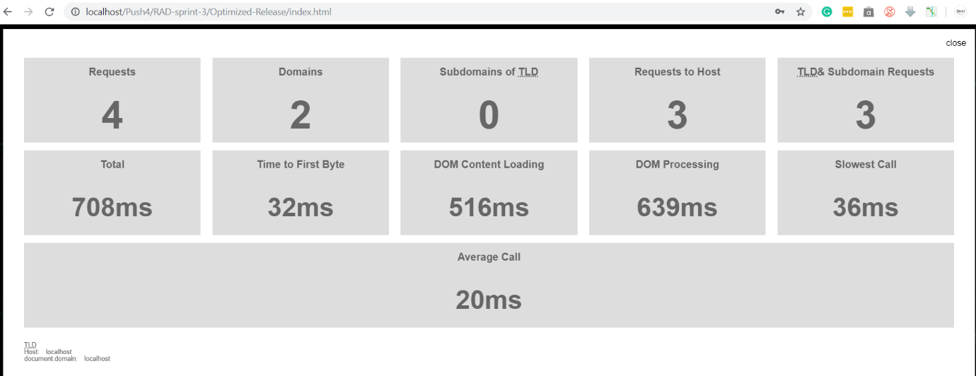

#### Admin.php

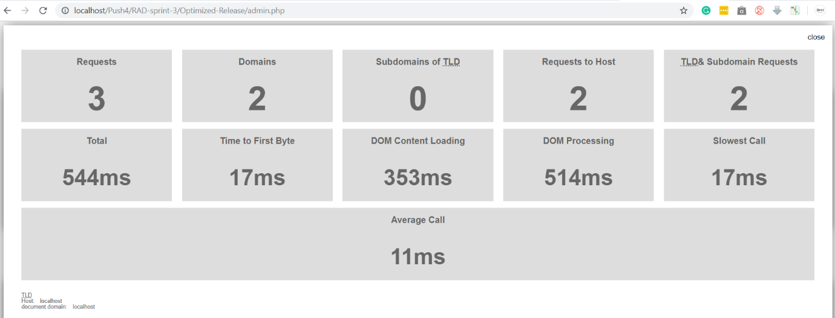

#### Member.html

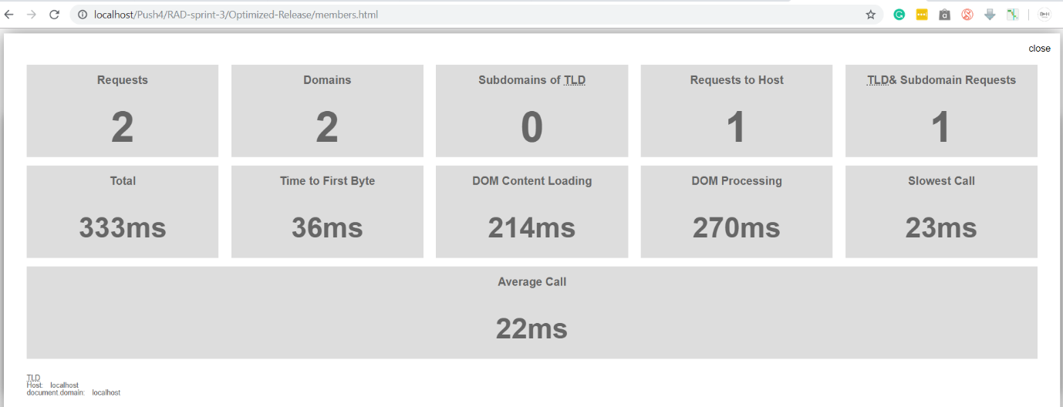

#### ShowTopTen.php

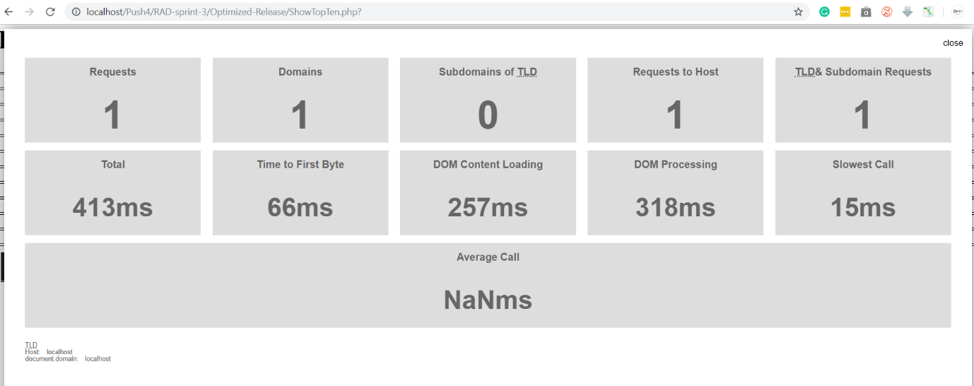

#### ShowTopTenGraph.php

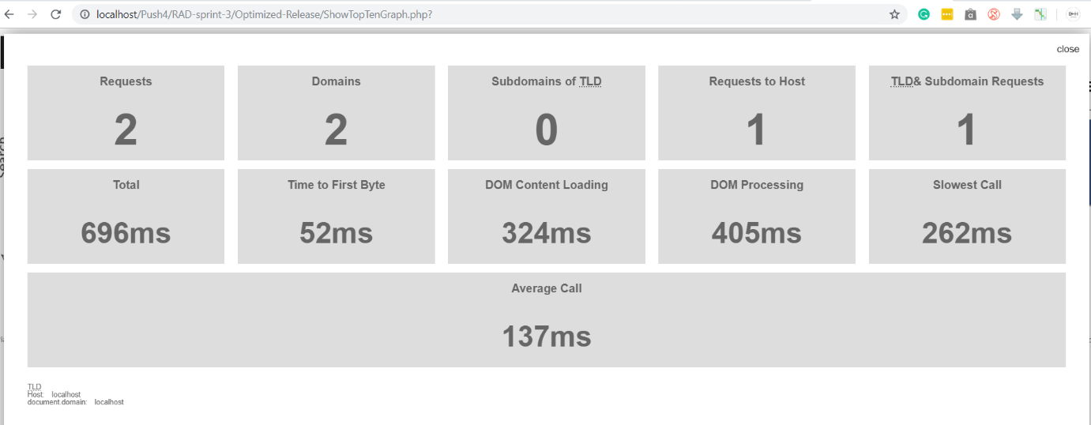

#### ShowTopTenRatings.php

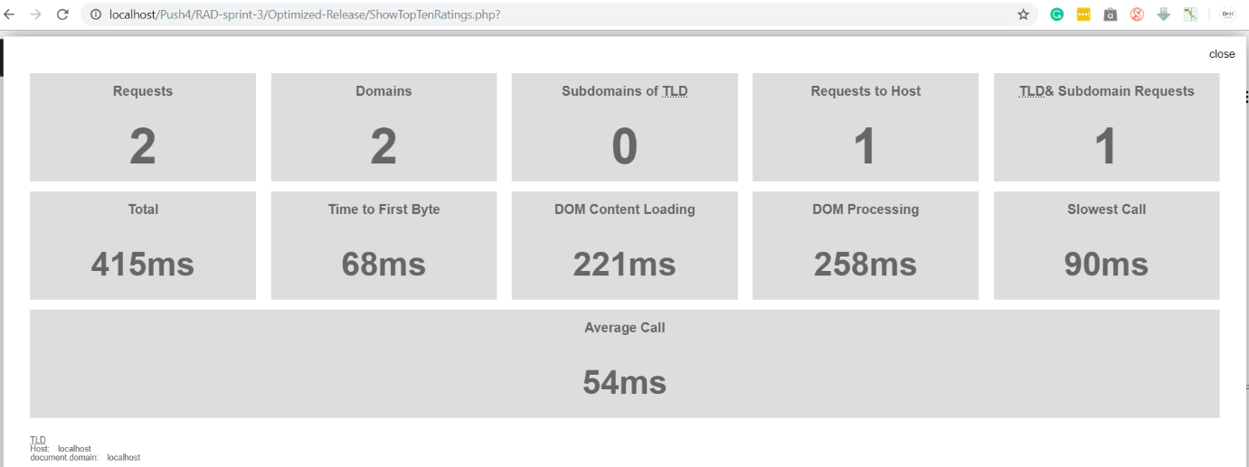

### Optimization Conclusion

The usage of the aforementioned tools has a large impact on the website, the total file size reduced by 57percent, this is in total (including optimization which was made to the source code and the images which are used as linked assets). In most cases, total load time was faster, however in the cases that is was not the slowest call times improve dramatically. Which leads to a lower overall average call time, understandably, these results can be influenced by a number of factors including which device or browser the site is accessed from as well as various servers differing operations or their current connection speeds.

## Project Management Plan

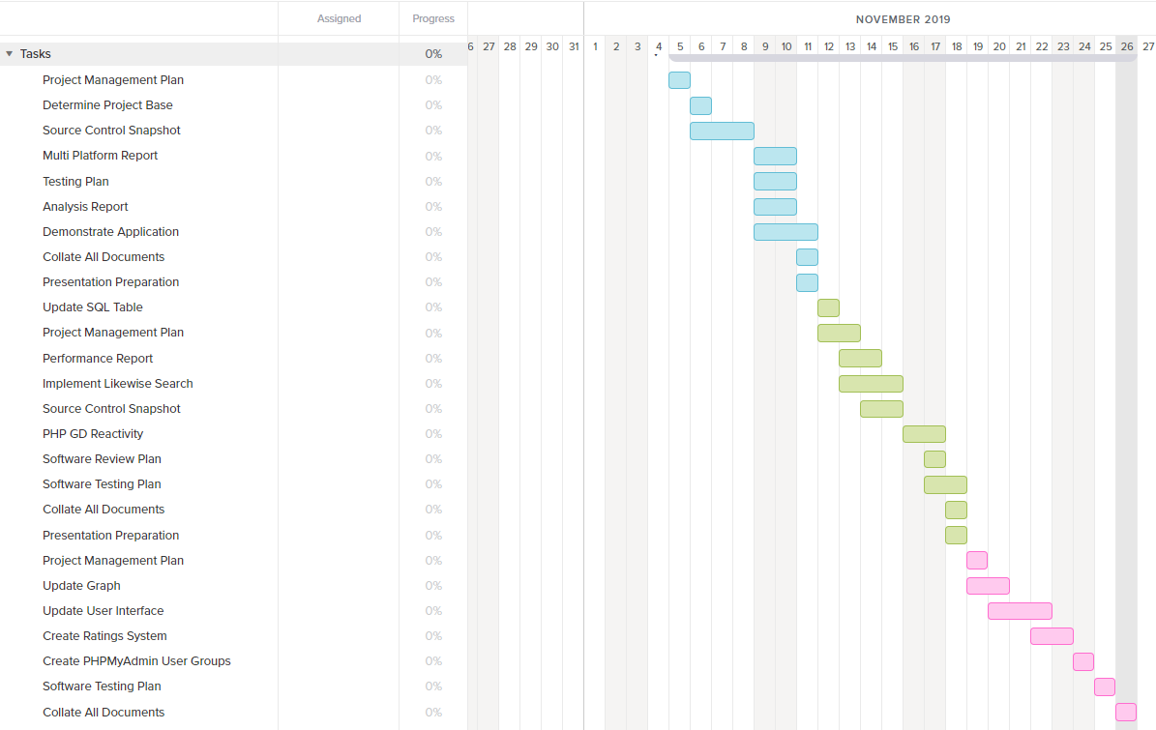

Plan started on the 19th of November and ended on the 26th of November. We generated this Gantt chart from teamgantt.com and for the rest of the project management used a task manager called Trello.

## Software Testing Plan

### Change Log

|  |  |  |  |
| --- | --- | --- | --- |
| **Version** | **Change Date** | **By** | **Description** |
| 3.4 | 19/11/19 | Wade, Sam | Added notification and newsletter functionality, changed graph page to have background |
| 4.0 | 22/11/19 | Bryce | Full design overhaul implemented |
| 4.1 | 23/9/19 | Bryce | Design improvements and minor fixes |
| 4.2 | 24/9/19 | Bryce, Sam | Favicon inclusion, design improvements, basic rating system added |
| 4.3 | 25/9/19 | Bryce, Sam, Wade | File structure cleanup, database design improvements, graph creation optimisations |
| 4.4 | 26/9/19 | Bryce, Wade, Sam | Button design changes, rating system overhaul, top 10 ratings pie chart creation, design improvements, output formatting overhaul |

### Introduction

This test plan is designed to be used within the 3rd and final week of RAD, iterating off all previous development plans, to ensure everything is up to par for the handover in the coming week. Through this document the correct procedures on how to create, test and deploy code will be discussed. For this project we are using the RAD methodology, which highly encourages following user feedback over following a set structure.

#### Scope

##### In-Scope

* Movie Database (This includes Installation / Configuration Testing and System / Integration Testing from CITE QA)
* Front-End Website (This includes Functional and Regression Testing, GUI and Usability Testing, Accessibility Testing, Compatibility Testing, Design choices and Performance Testing from CITE QA)
* Responsiveness of website
* Multi Device Support (Desktop, Tablet, Mobile Phone)
* Overall functionality of website
* Integration of new systems into existing project via GitHub

##### Out of Scope

* Notification functionality (was heavily designed last week, does not need further changes in this weeks design plan)
* Searching functionality (database structure for movie list is finalized and will not need further additions, making changing that page logic wise is useless)

#### Quality Objective

* Ensure the Application Under Test (AUT) conforms to functional and non-functional requirements
* Ensure the AUT meets the quality specifications defined by the client
* Bugs/issues are identified and fixed before making a development “live”
* Reactiveness of the site is working
* Design of site is easy to understand and neat for users to navigate

#### Roles and Responsibilities

* Scrum Master: Lead the team and ensure all work is done on time
* Team Member: Works under the Scrum Master to work on the week’s work

#### Test Methodology

#### Overview

The reason we chose the RAD methodology was due to its flexible design and ease of use for the project provided. It also allows for us to constantly update it according to the week’s design frame and stay flexible with issues that might arise

#### Test Levels

##### Unit/Component Testing

Making sure that the base project has no errors that carried over from the last iteration.

##### Integration Testing

We test with the additional features in place very broadly to ensure that the core functionality is implemented, and previous functionality is maintained.

##### System Testing

More in-depth testing is done to make sure that in a production state no issues would occur.

##### Acceptance Testing

We test against the marking guide to ensure that anything asked by the client will be functional when presented.

#### Bug Triage

The goal of the triage is to

● To define the type of resolution for each bug

● To prioritize bugs and determine a schedule for all pending bugs.

#### Suspension Criteria & Resumption Requirements

##### Suspension Criteria:

● A bug is found during testing (Suspend that page)

● Testing tools fail to work (Suspend all)

● Testing system failure (OS Issue) (Suspend all)

● Tester has an out of work emergency (Suspend all)

##### Resumption Requirements

● The bug was fixed

● You got the testing tool to work

● Re-install OS

● Wait until issue is resolved and tester is free again.

### Test Completeness

We deem testing complete once we get:

● 100% test coverage

● All Manual & Automated Test cases executed

● All open bugs are fixed or will be fixed in next release

● All devices have been tested

● All pages have been looked through

#### Test Deliverables

The test artefacts we will be using are:

* Test Plan
* Test Cases
* Bug Reports
* Test Strategy
* Test Metrics
* Customer Sign Off

### Resource & Environment Needs

#### Testing Tools

Tools we will be using to test bugs are:

● XAMPP (Host the site and MySQL)

● Firefox (Size the website to emulate other devices)

● Google Chrome (Usage of performance extension)

● Microsoft Edge (Ensure design works well across multiple browsers)

● Trello (Report Bugs)

#### Test Environment

The following software is required to run the tests:

● Windows 7 and above

### Terms & Acronyms

|  |  |
| --- | --- |
| **TERM/ACRONYM** | **DEFINITION** |
| API | Application Program Interface |
| AUT | Application Under Test |
| RAD | Rapid Application Development |

## Testing Documentation

***All testing has been undertaken on the optimized sites codebase***

### Admin Log-in and User Groupings with individual accesses

Admin log-in can be accessed from the button in the top right of Index.Html

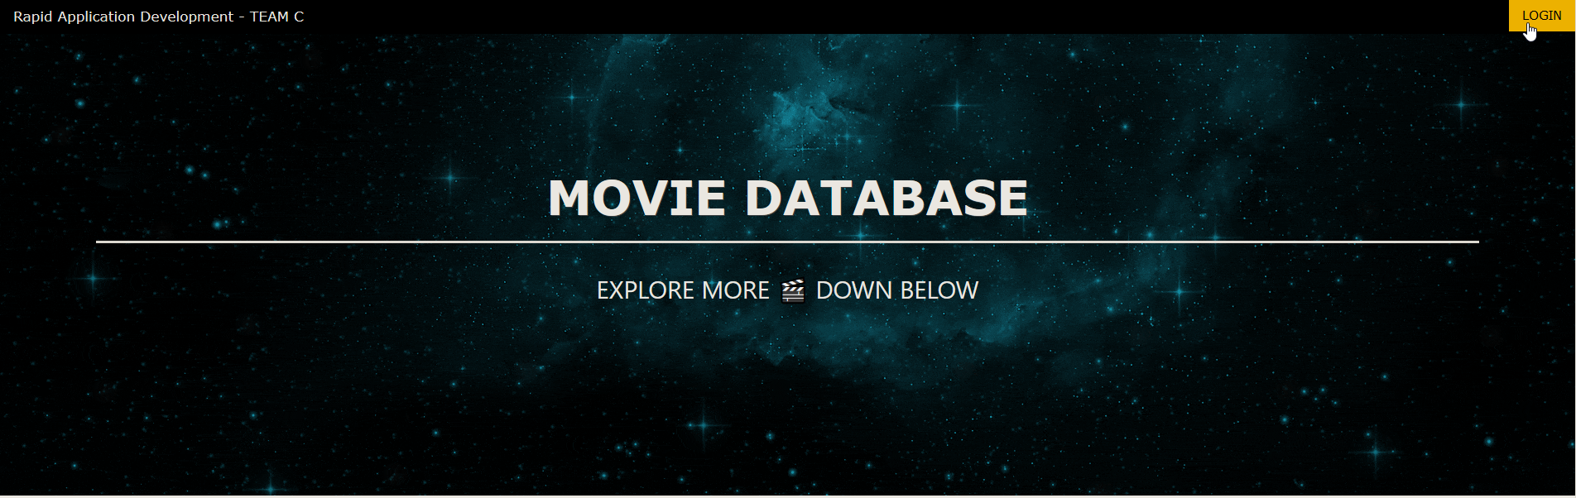

User/Pass is admin: admin

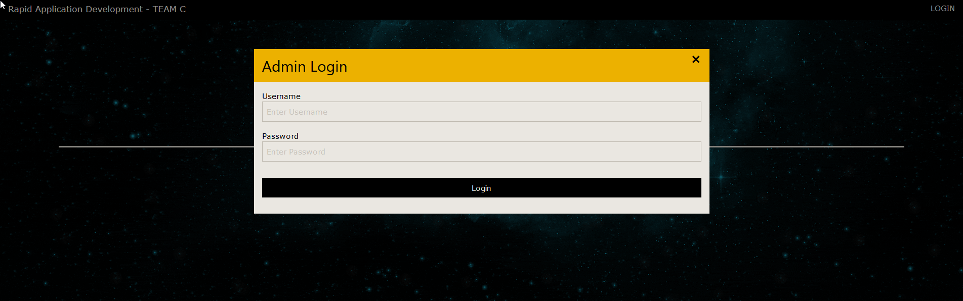

Log-in leads to communication and DBMS access

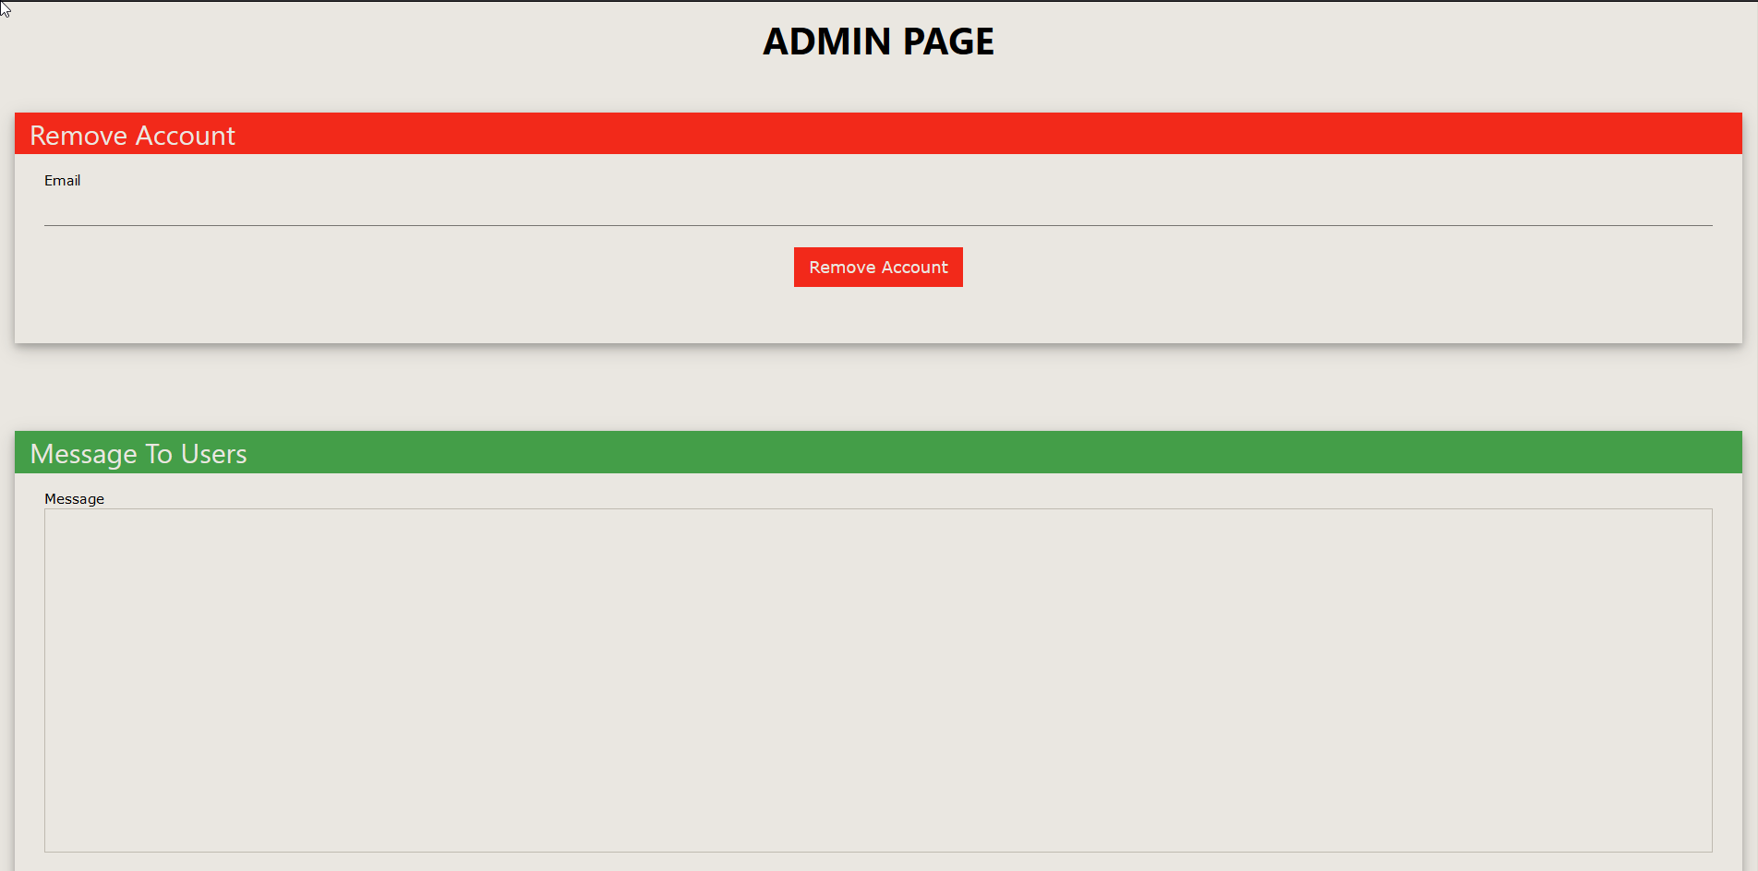

The Access DMBS button is available at the bottom of this page and allows immediate access to admins.

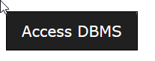

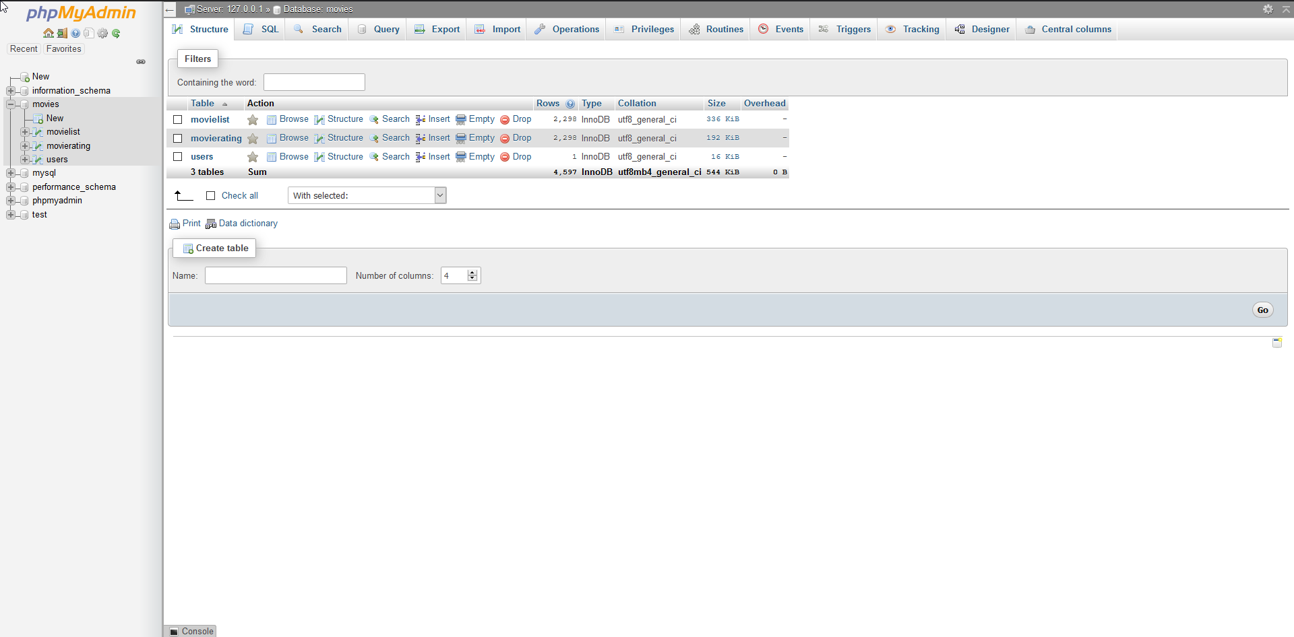

From here, the admin can select the privileges heading in order to create, modify and remove user groups

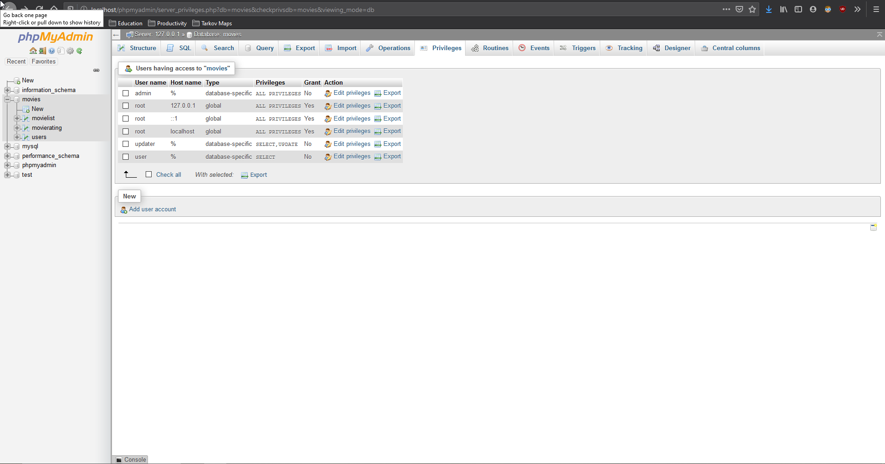

### Historic Data Collection and Output To User

Now, when SearchDatabase.php is run, the information is outputted into a table, the final row of this table has a drop down box, the user sets either like or dislike in the drop down box, then clicks send on the button inside of the same cell, at this point the user will be told their rating is applied and the like or dislike columns on the database are incremented depending on the dropdowns value.



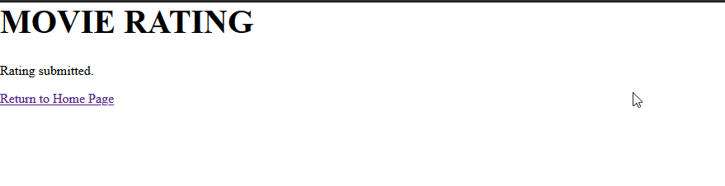

Matrix film ID has incremented in the like column

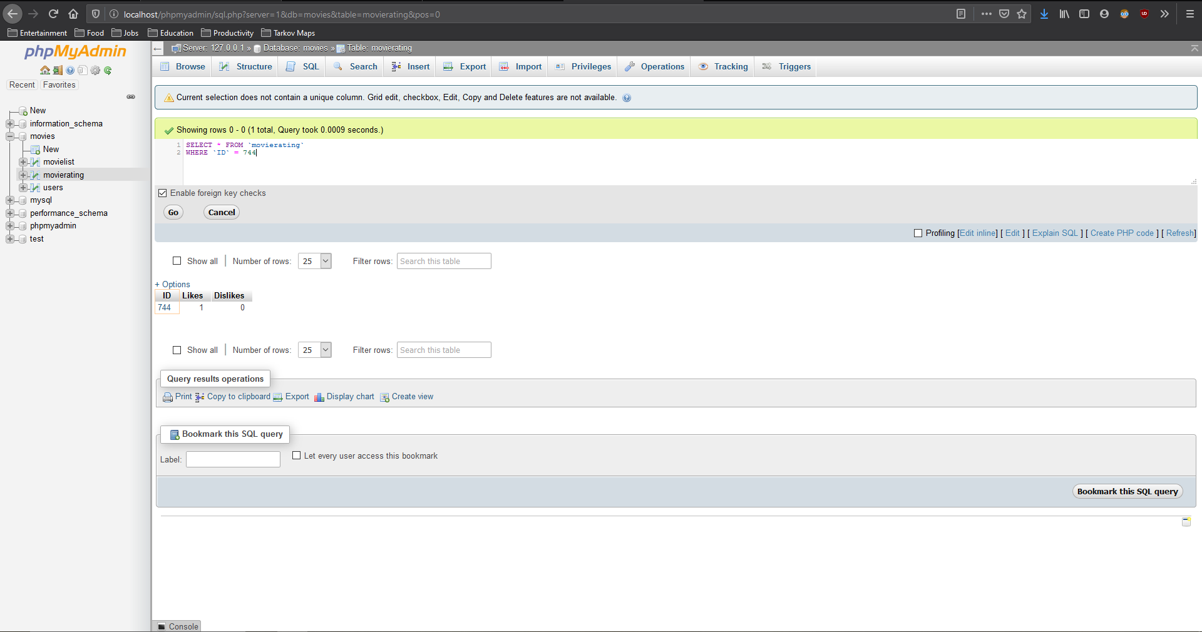

The collected amount of likes is then used to draw the pie chart for users when it is requested from the ”Pie chart” button is pressed on the Index.html page

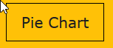

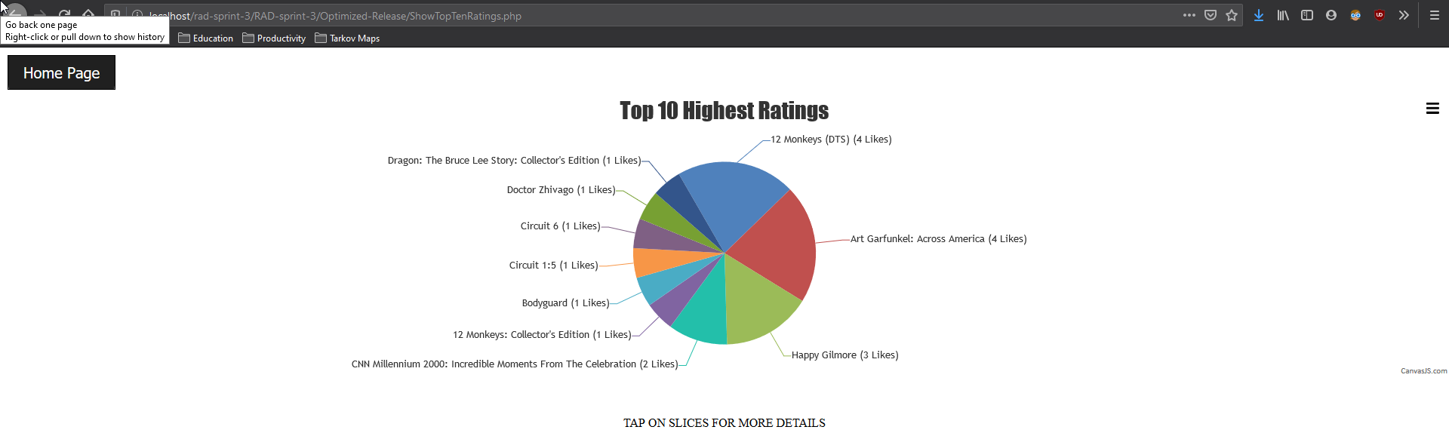

### Responsiveness Re-Testing

It was decided that due to implementation of new outputting in addition major visual overhaul to the website that responsiveness testing was undertaken again in order to see if the newly implemented systems had any impact on legacy code from previous sprints. The pages tested were Index.html, SearchDatabase.php, Admin.php and ShowTopTenRating.php

***Tested Sizes were:***

* ***Samsung s9 (360x740px)***
* ***Ipad (768x1024)***
* ***Browser (1920x1080)***

#### Index.Html

##### Samsung s9

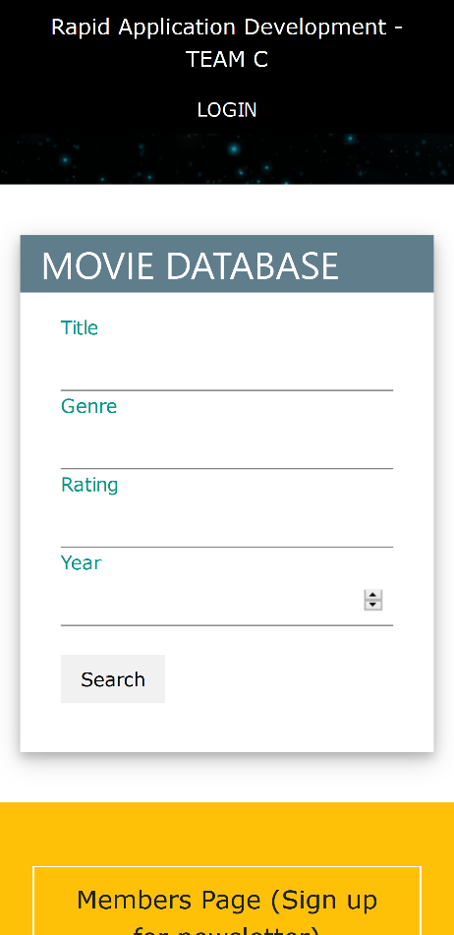

##### Ipad

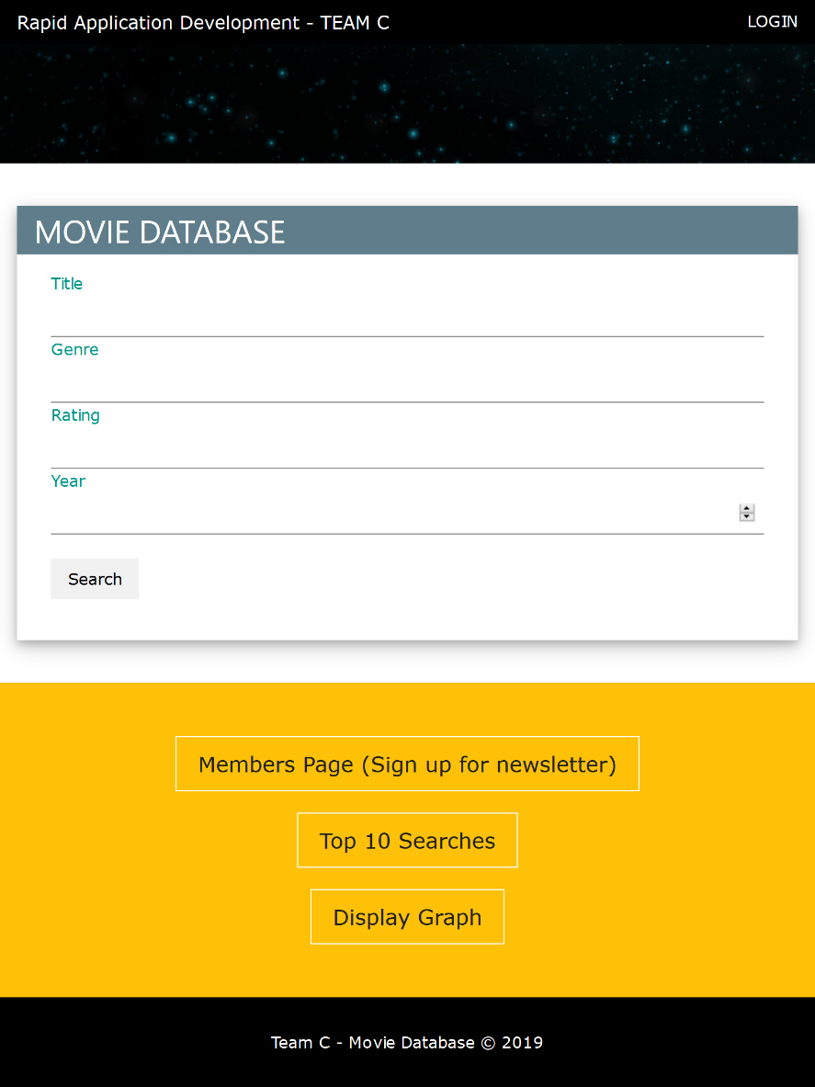

##### Browser

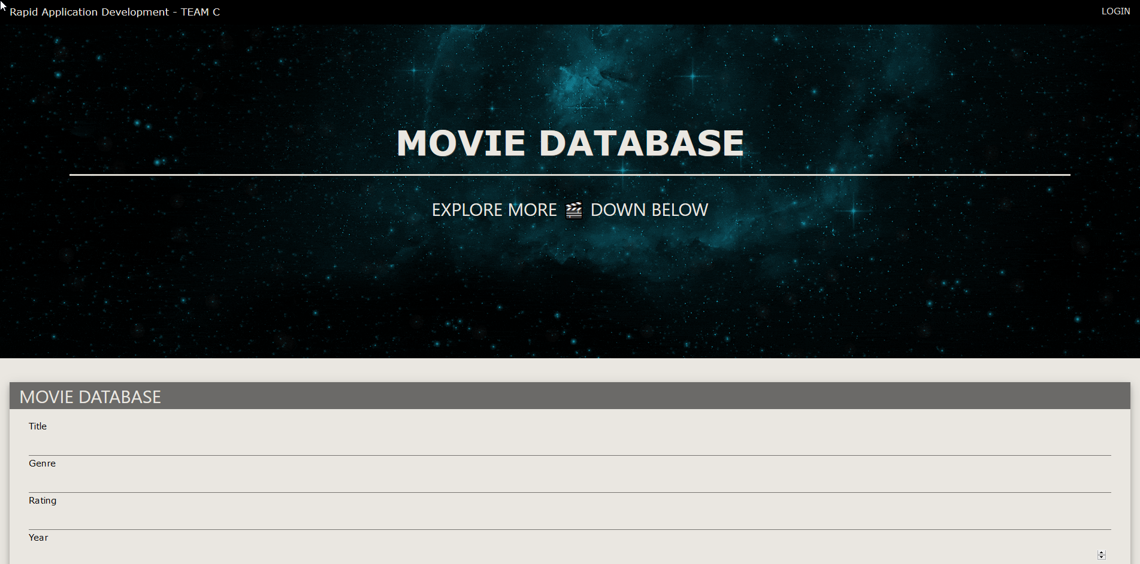

#### SearchDatabase.php

##### Samsung s9

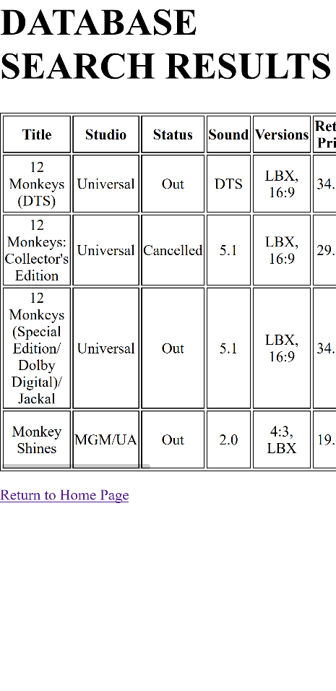

On devices widths of < 560px, the table has as overflow value set, meaning that a horizontal scrollbar will appear at the bottom of the div element containing the table, this makes it so that the table can respond to be viewable in most device widths

##### Ipad

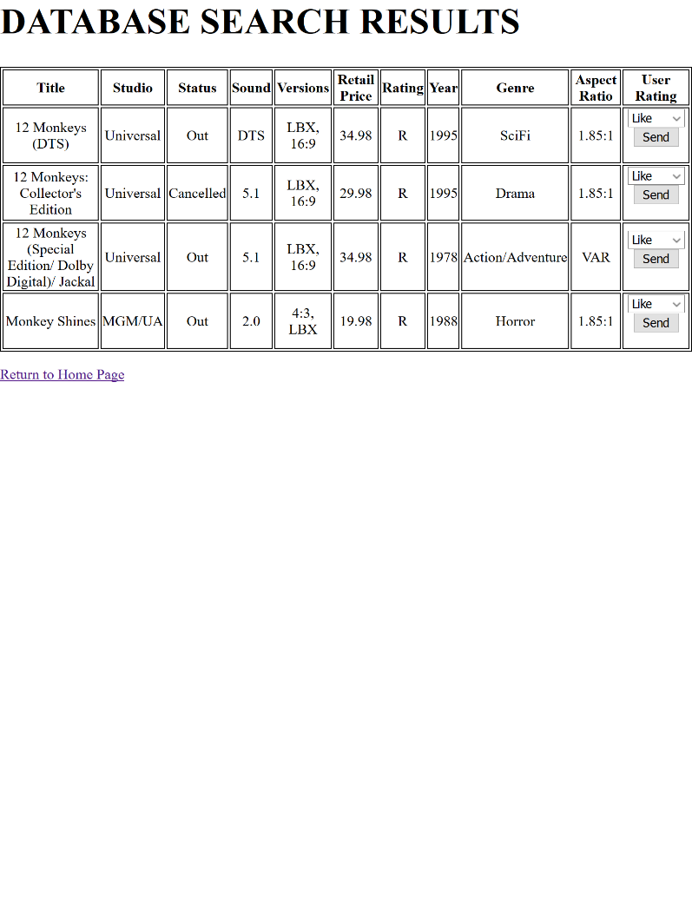

##### Browser

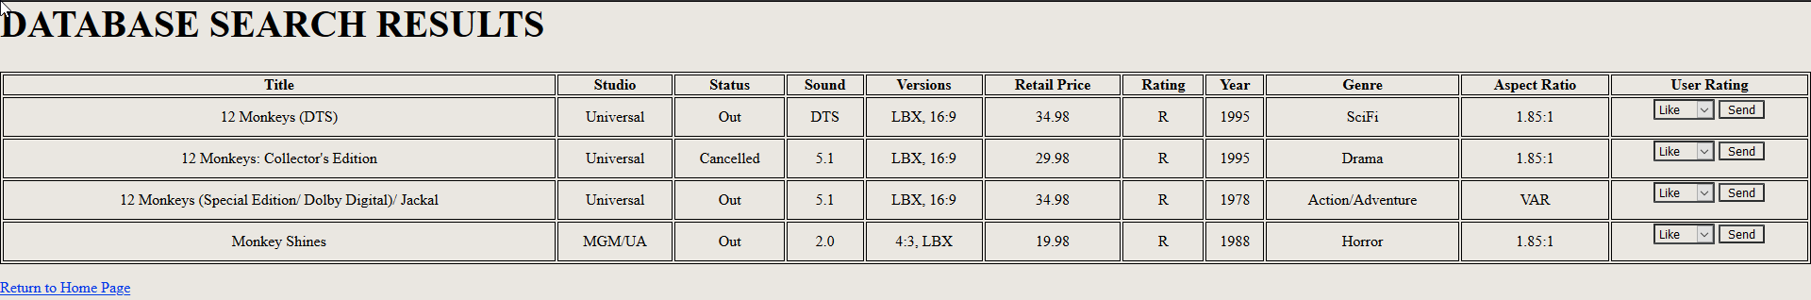

#### Admin.php

##### Samsung s9

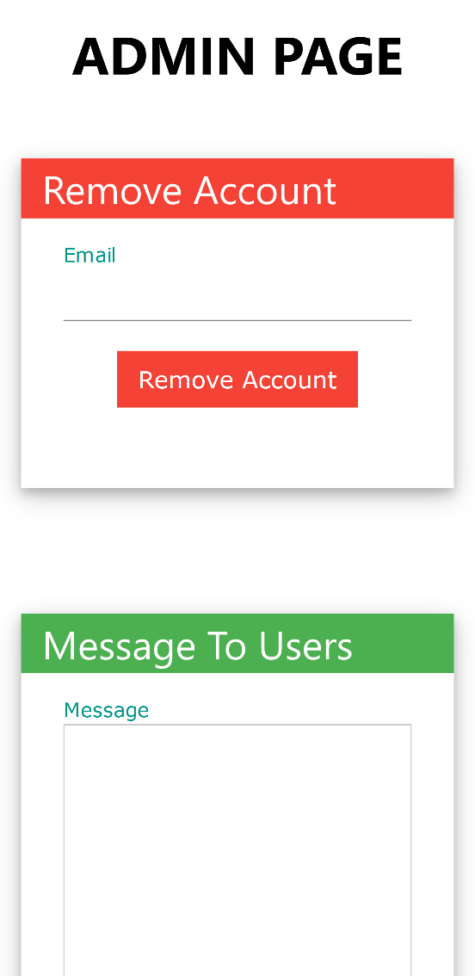

##### Ipad

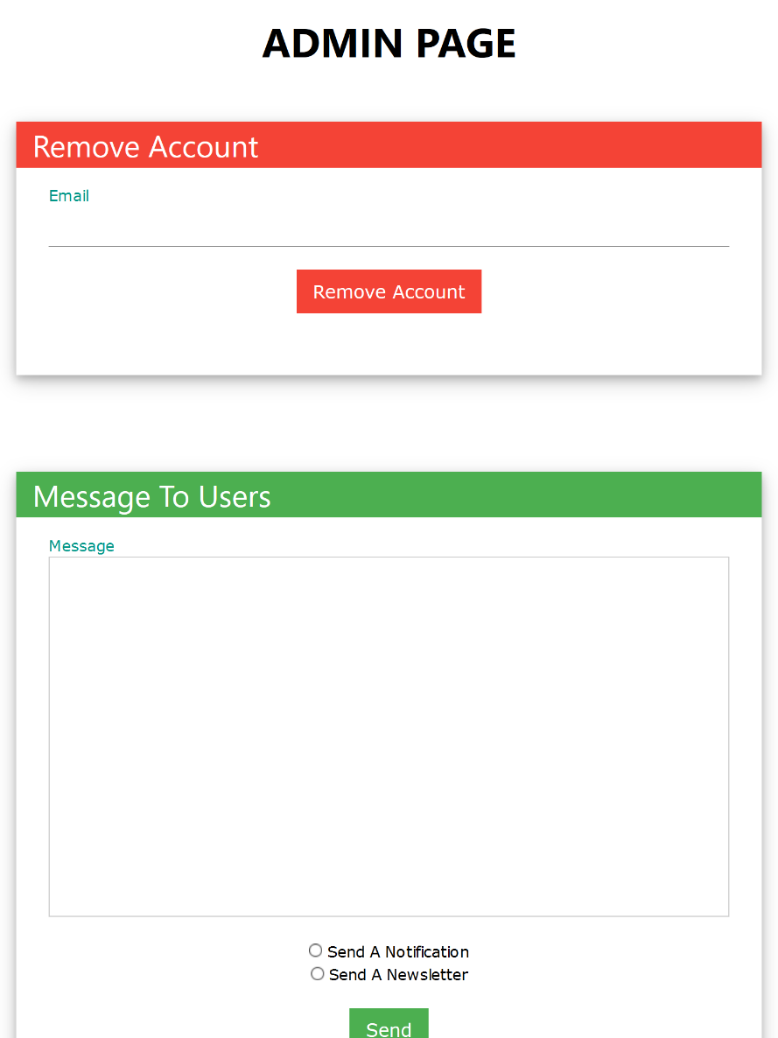

##### Browser

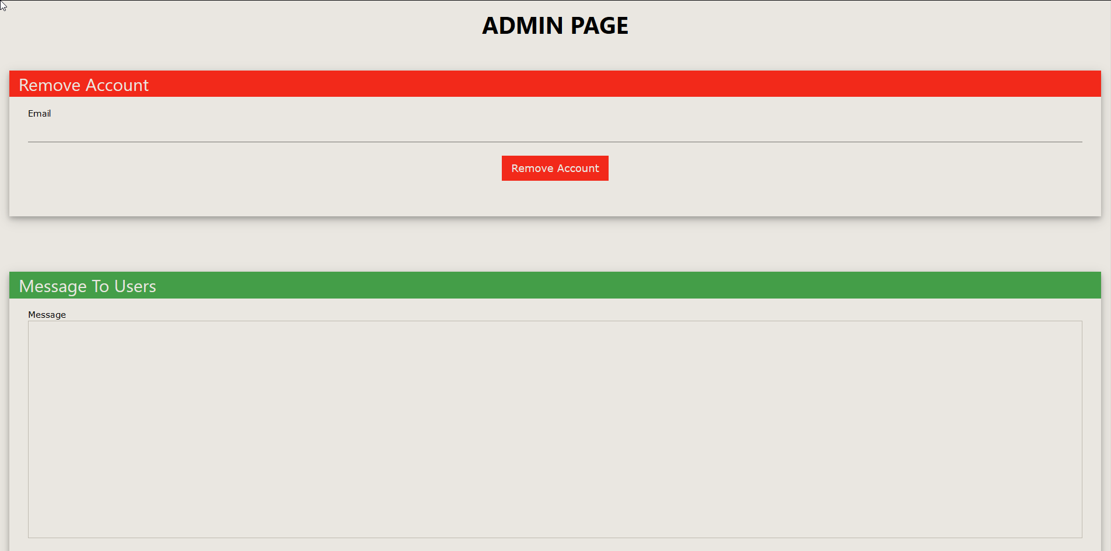

#### ShowTopTenRating.php

##### Samsung s9

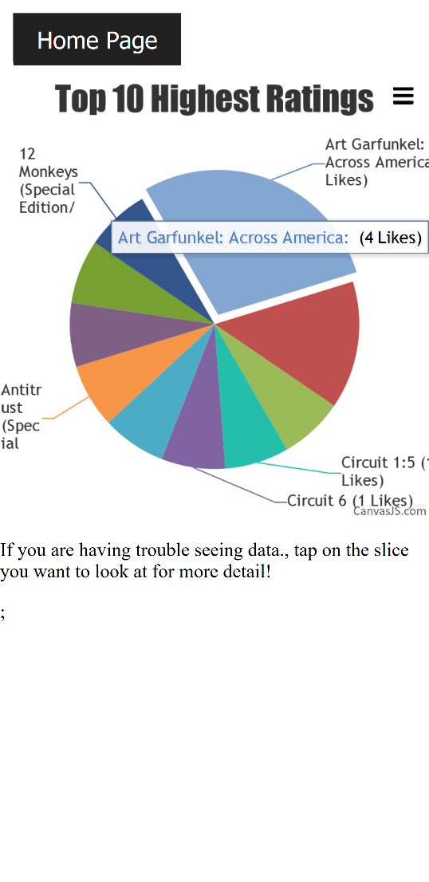

##### Ipad

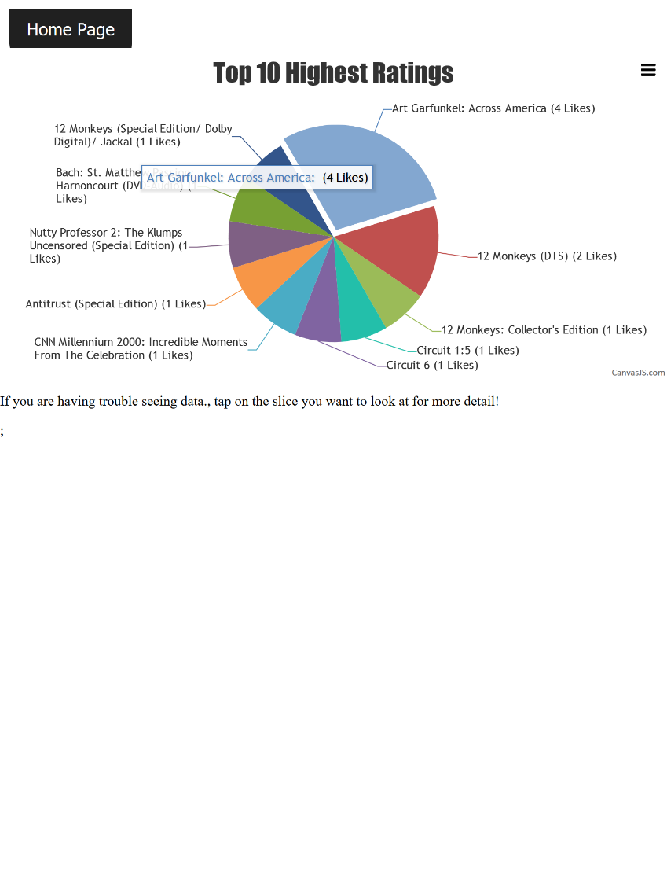

##### Browser

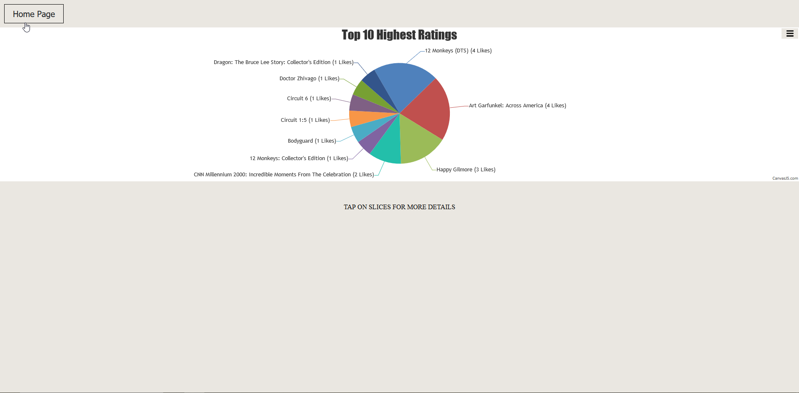

### Testing Conclusion

All testing was deemed to have passed. New features were added, which included database grouping, admin access and storage and then output of historical data pertaining to likes to users. Additionally, several pages received major visual and functional overhaul and responsiveness was tested on these pages, the site is responsive on all tested devices. The final changes to the site will be made prior to client hand-over

# Client Handover

## Source Control Snapshots

### Sprint-3

### 

### wcag-handover

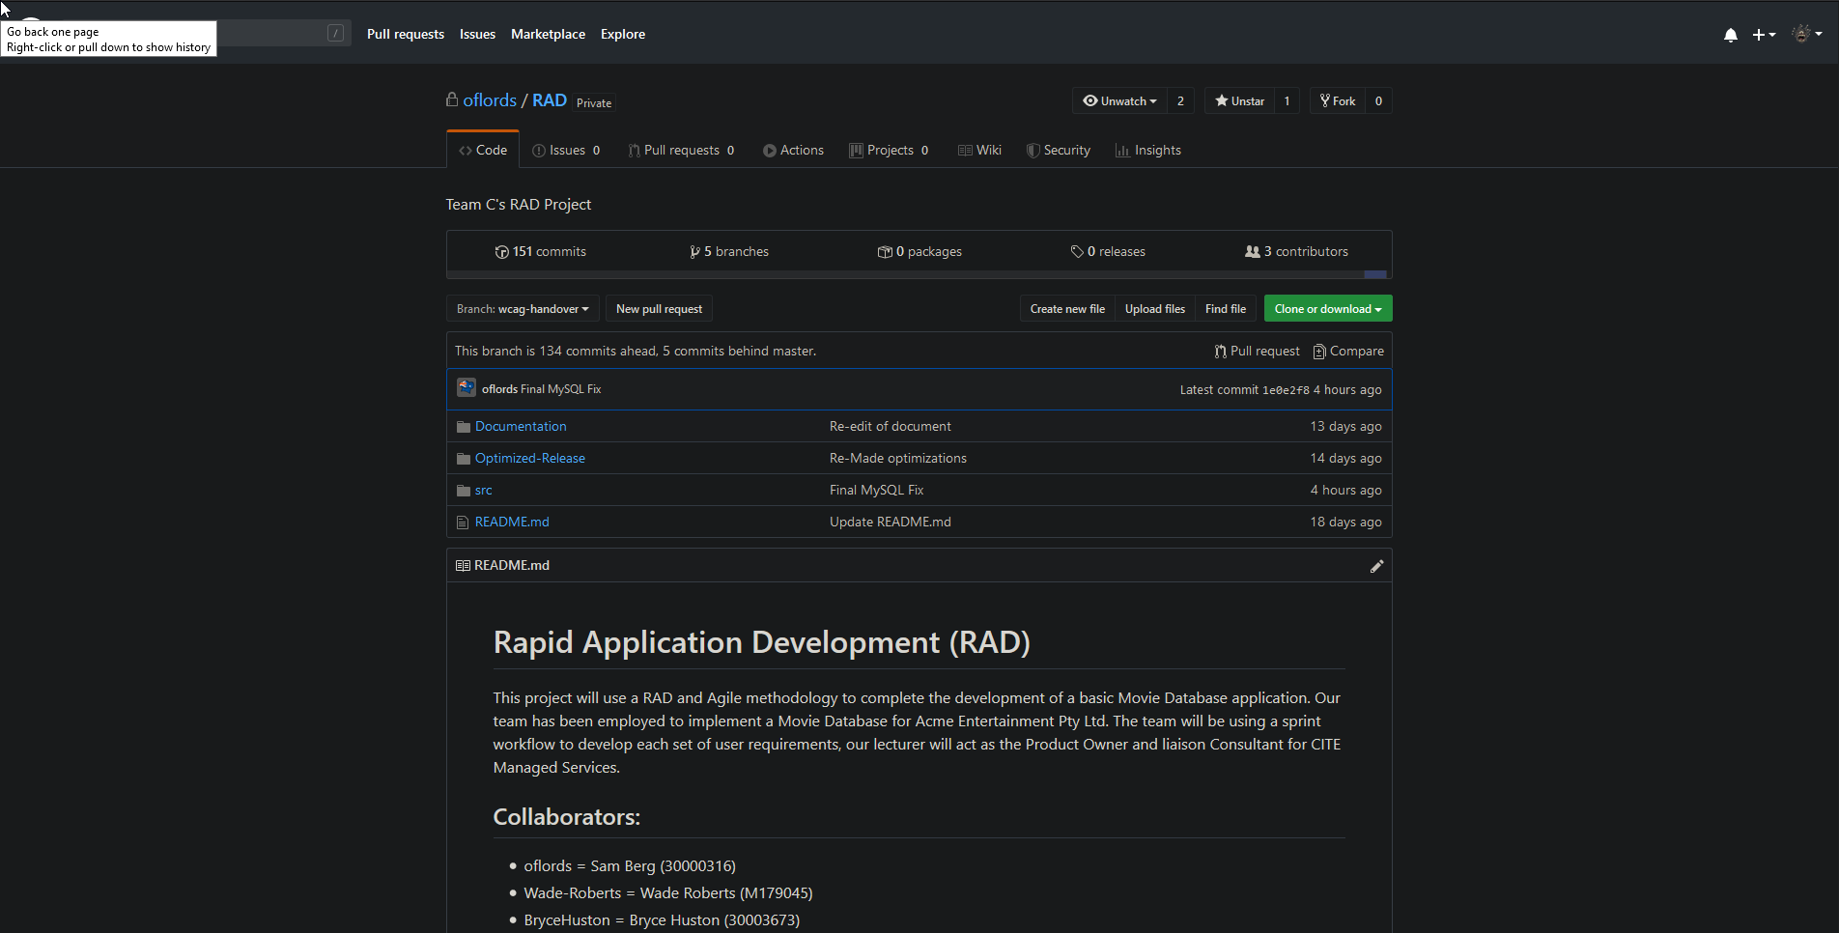

## Software Review Report

### Development Quality

To ensure quality across all versions, we used testing plans to make sure that everything that was presented was to a high quality and had already been tested against the standards before presentations. We also utilized the use of Trello to track bugs, allowing no issues to go under the radar after being detected by assigning it to a member of the team and setting due dates.

### Processes of Quality

Processes included:

• Testing Plan

• Trello Bug Tracking

• GitHub Source Control

• Weekly Presentations (Fresh pair of eyes)

### Code Testing Process

1. Identify Issue/Feature to be added

2. Map out implementation around current codebase

3. If current codebase needs to be changed drastically to allow for its implementation, inform other users of group regarding overhaul of old system

4. Implement bleeding edge build of new feature

5. Test alongside current codebase

6. Test in different environment (Other team member’s computers)

7. Tweak to ensure compatibility/functionality

8. Mark as complete on Trello and push code to GitHub

### Future Modifications/Requirements

The site in its current state is somewhat incomplete for a public rollout. While the code is polished and fully functional it assumes administrators of the service understand how to setup their backend for use with the mail function and how to add movies themselves. If a user wanted to set this up with no deep understanding of computers, they would not be able to make use of all the features.

To combat this, making a setup script for it to be used on Linux distributions (.sh) would help allow less computer savvy administrators get access to all features. Another thing that would help combat this is the addition of a movie adding section to the admin page, allowing for admins to very easily keep the website up to date. A change log for the adding of new movies will also help users tell when movies they might want to give a rating are available.

Building off the idea of adding more movies, making functionality to scan certain web APIs for an ever updating list of movies would also help keep the database up to date with no form of administrator access or maintenance. Adding of other things such as proper user interaction, a theme selector and audio readouts of results to further comply with WCAG.

Client Requirements

• The application functions correctly on chosen platform

Program works perfectly via XAMPP on multiple hardware’s.

• Administrators can access the Db

An admin page allows for manipulation of the database via the website itself and PHPMyadmin via user accounts.

• Members can join the Movie Database

A member page allows for signing up on the site to receive emails.

• WCAG is included in the final design

WCAG is used to allow for easy navigation for the less fortunate.

• Ensure all documentation is properly formatted

All documentation has been created over the weeks and implemented.

• Ensure all topics are covered using common terminology

All documentation has been previously checked to ensure easy understandingfor non tech savvy readers.

• The presenter can explain the functions for administrators and data display

All members of the RAD development team have been properly educated throughout the year to have full competence in the fields required for this task.

• All Testing has been documented

All testing documents can be found within the master document.

## Project Management Plan

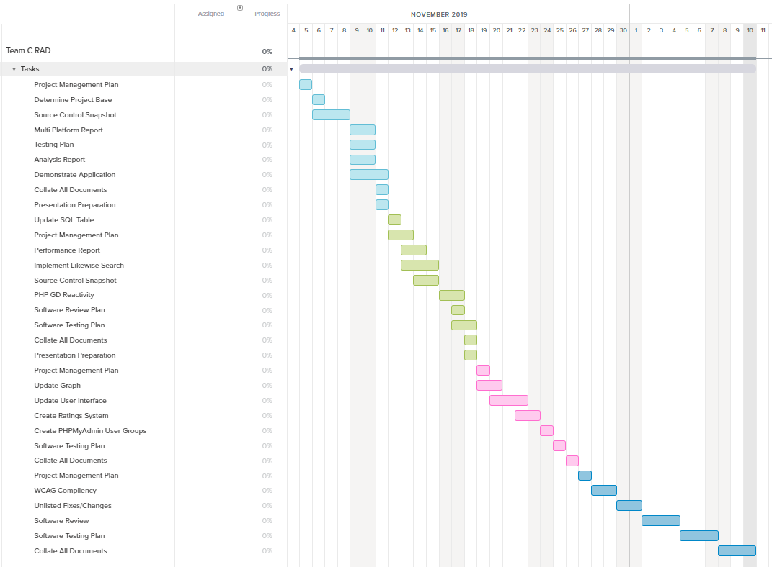

This Gantt chart was made using information stored on Trello with the TeamGantt plug in. this chart above encompasses the entire development from sprint-1 through to client hand over, the new addition is from 27/11/2019 to 10/12/2019.

**Link to Trello**: https://trello.com/b/ol7IYroU/agile-sprint-board

## Software Testing Plan

### Change Log

|  |  |  |  |
| --- | --- | --- | --- |
| **Version** | **Change Date** | **By** | **Description** |
| 1.0 | 07/11/19 | Sam | Updated the index.html to allow for better responsiveness |
| 2.0 | 10/11/19 | Sam | Allowed all php files to use the html <p> tag to conform to the responsiveness |
| 2.1 | 10/11/19 | Wade | Changed values to look better on mobile devices |
| 2.1.1 | 11/11/19 | Bryce | Fixed PHP GD graph |
| 2.2 | 12/11/19 | Sam | Updated database structure |
| 3.0 | 14/11/2019 | Sam | Added member creation |
| 3.1 | 16/11/19 | Sam, Wade | Updated page design, search functionality and added functioning admin page |
| 3.2 | 17/11/19 | Bryce | Changed github structure |
| 3.3 | 18/11/19 | Sam | Security changes, graph scalability and changed database structure again |
| 3.4 | 19/11/19 | Wade, Sam | Added notification and newsletter functionality, changed graph page to have background |
| 4.0 | 22/11/19 | Bryce | Full design overhaul implemented |
| 4.1 | 23/9/19 | Bryce | Design improvements and minor fixes |
| 4.2 | 24/9/19 | Bryce, Sam | Favicon inclusion, design improvements, basic rating system added |
| 4.3 | 25/9/19 | Bryce, Sam, Wade | File structure cleanup, database design improvements, graph creation optimisations |
| 4.4 | 26/9/19 | Bryce, Wade, Sam | Button design changes, rating system overhaul, top 10 ratings pie chart creation, design improvements |
| 4.4.1 | 27/9/19 | Wade | Fixed Corrupt File |
| 5.0 | 3/12/19 | Sam, Bryce, Wade | WCAG Compliance across 80% of code, cleanup of CSS |
| 5.1 | 10/12/19 | Sam, Bryce, Wade | Final push of code, WCAG and HTML improvements |

### Introduction

This test plan is designed to be used within the final part of the project, iterating off all previous development plans, to provide a smooth handover with 0 errors and easy access for less able individuals. Through this document the correct procedures on how to create, test and deploy code will be discussed. For this project we have been using the RAD methodology, which highly encourages following user feedback over following a set structure. As we have not had much to work on through the week, the RAD method was less applied then in other weeks.

#### Scope

##### In-Scope

* Movie Database (This includes Installation / Configuration Testing and System / Integration Testing from CITE QA)
* Front-End Website (This includes Functional and Regression Testing, GUI and Usability Testing, Accessibility Testing, Compatibility Testing, Design choices and Performance Testing from CITE QA)
* Responsiveness of website
* Multi Device Support (Desktop, Tablet, Mobile Phone)
* Overall functionality of website
* Integration of new systems into existing project via GitHub
* Notification functionality
* Website Design

###### Out of Scope

* Searching functionality (database structure for movie list is finalized and will not need further additions, making changing that page logic wise is useless)
* MySQL data structure (does not affect the WCAG additions so no point looking into it this week)

#### Quality Objective

* Ensure the Application Under Test (AUT) conforms to functional and non-functional requirements
* Ensure the AUT meets the quality specifications defined by the client
* Bugs/issues are identified and fixed before making a development “live”
* Reactiveness of the site is working
* Design of site is easy to understand and neat for users to navigate

#### Roles and Responsibilities

* Scrum Master: Lead the team and ensure all work is done on time (No designated SCRUM master this week as very little needs to be worked on)
* Team Member: Works under the Scrum Master to work on the week’s work.

### Test Methodology

#### Overview

The reason we chose the RAD methodology was due to its flexible design and ease of use for the project provided. It also allows for us to constantly update it according to the week’s design frame and stay flexible with issues that might arise

##### Test Levels

###### Unit/Component Testing

Making sure that the base project has no errors that carried over from the last iteration.

###### Integration Testing

We test with the additional features in place very broadly to ensure that the core functionality is implemented, and previous functionality is maintained.

###### System Testing

More in-depth testing is done to make sure that in a production state no issues would occur.

###### Acceptance Testing

We test against the marking guide to ensure that anything asked by the client will be functional when presented.

#### Bug Triage

The goal of the triage is to

● To define the type of resolution for each bug

● To prioritize bugs and determine a schedule for all pending bugs.

#### Suspension Criteria & Resumption Requirements

##### Suspension Criteria:

● A bug is found during testing (Suspend that page)

● Testing tools fail to work (Suspend all)

● Testing system failure (OS Issue) (Suspend all)

● Tester has an out of work emergency (Suspend all)

##### Resumption Requirements

● The bug was fixed

● You got the testing tool to work

● Re-install OS

● Wait until issue is resolved and tester is free again.

### Test Completeness

We deem testing complete once we get:

● 100% test coverage

● All Manual & Automated Test cases executed

● All open bugs are fixed or will be fixed in next release

● All devices have been tested

● All pages have been looked through

### Test Deliverables

The test artefacts we will be using are:

* Test Plan
* Test Cases
* Bug Reports
* Test Strategy
* Test Metrics
* Customer Sign Off

### Resource & Environment Needs

#### Testing Tools

Tools we will be using to test bugs are:

● XAMPP (Host the site and MySQL)

● Firefox (Size the website to emulate other devices)

● Google Chrome (Usage of performance extension)

● Microsoft Edge (Ensure design works well across multiple browsers)

● Trello (Report Bugs)

#### Test Environment

The following software is required to run the tests:

● Windows 7 and above

Terms & Acronyms

|  |  |
| --- | --- |
| **TERM/ACRONYM** | **DEFINITION** |
| API | Application Program Interface |
| AUT | Application Under Test |
| RAD | Rapid Application Development |

## Testing Documentation

### Rating Confirmation (Before, After)

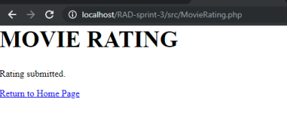

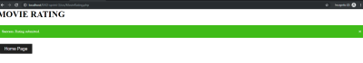

### User Adder (Before, After)

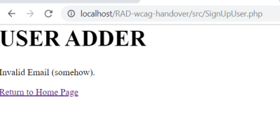

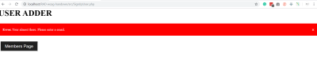

### Wcag Compliance (Button Example, Image Example)

